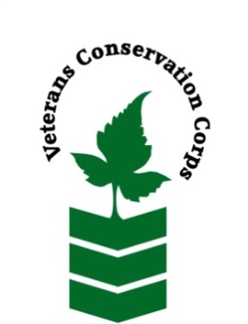
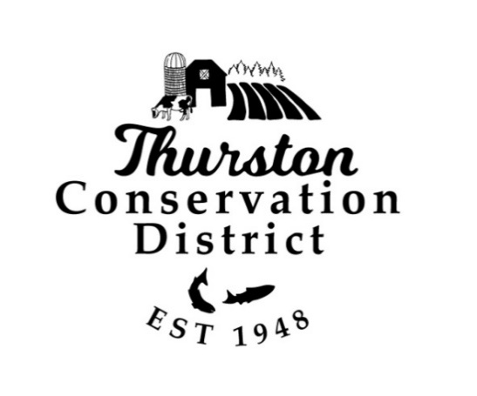
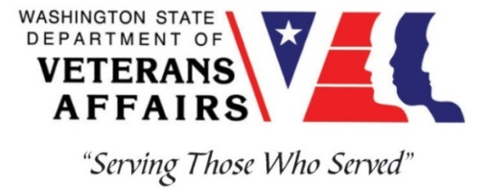

2918 Ferguson St SW
Tumwater, WA 98512
www.thurstoncd.com
_____________________________________________________________________________________
Veterans Conservation Corps Crew Internship
with
Thurston Conservation District

Program Overview
Thurston Conservation District is a non-regulatory public organization that educates and assists the citizens of Thurston County in the management of natural resources for the benefit of present and future generations. By inspiring voluntary, incentive-based conservation activities on private lands, we partner with our community to restore ecosystems, ensure thriving local agriculture and build resiliency in the face of a changing climate.

Location: Thurston Conservation District, 2918 Ferguson St SW, Suite A, Tumwater, WA 98512
Compensation: $2,400 monthly stipend to assist with living expenses
Work Hours: Monday-Friday, 8:00am-4:30pm – Can be flexible and some weekend and evening work may be required.
Duration: 1 year
Start Date: September 2023, position open until filled

Position Summary
We are seeking a Veterans Conservation Corps (VCC) member to assist with the monitoring and restoration of rare prairie habitat across the Chehalis watershed (Thurston, Lewis, and Grays Harbor Counties) in Southwest Washington. The VCC member will work to promote responsible grazing practices and educate landowners about conservation programs. This position requires a sound work ethic, strong interpersonal skills, and a positive attitude. This position will require evening and weekend work, on occasion. We are committed to providing a meaningful experience for the VCC member and will support any veteran-specific needs that are appropriate to each Individual’s capabilities and condition during enrollment in program. The majority of the time will be spent in Thurston County while coordinating with other interns working in Lewis and Grays Harbor Counties.

This Thurston County based position will support several program areas specifically:
- Support the enhancement and expansion of Thurston Conservation Districts agricultural equipment rental program to benefit prairie landowners and other community members.
- Assist in the writing of conservation plan documents that support property managers in stewarding their landscapes. These plans include conservation grazing plans, irrigation management plans, and Individual Stewardship Plans.
- Assistance with TCD and partner events including, but not limited to, conferences and workshops, annual native plant sales, legislative tours and outreach, and regular SW WA Grazing Association events.

Schedule and Compensation
Location: Tumwater, WA with travel to sites in rural Thurston County, and occasional travel to sites in Lewis and Grays Harbor Counties
Work Hours: Monday-Friday, 8:00am-4:30pm – Hours are flexible; some weekend and evening work may be required.
This 12-month internship will begin as soon as possible (position open until filled), and includes a stipend of $2400/month for a full-time internship (~40 hours/week) to assist with living expenses.

Responsibilities
VCC member will serve with Thurston Conservation District and partnering agencies to carry out the following duties:
- Restore native prairie habitat through mowing, prescribed burning, invasive species removal (e.g., herbicide application, brushcutting, etc.), and native plant seeding
- Collect field data on plant, pollinator, and bird communities
- Support project implementation through field season preparation, literature reviews, and data entry/management
- Communicate with landowners about conservation grazing techniques and conservation programs
- Support farm equipment rental and maintenance
- Work with Thurston Conservation District employees on other projects to gain experience and knowledge of other duties and opportunities conservation districts are involved with.

Training Opportunities

All necessary training required to perform the essential functions/duties is provided on the job.
In addition to on-the-job training, this position may include the following formal trainings and certifications to aid in personal & professional development:
- NWCG Firefighter type II (Crew member) Certification
- Washington State Pesticide Applicators License
- Plant identification
- Habitat restoration and vegetation management techniques
- Chainsaw and brush cutting training
- Environmental conservation conferences/symposiums/workshops
- Growing your veteran-owned small business
- Grazing management
- Whole Farm Planning and Agricultural Entrepreneurship
- Posttraumatic Growth Training
- PTSD/TBI/Mental Health/ Suicide Awareness & Prevention
- Veteran Peer Support Training
- Other trainings/certifications as available and desired by intern

Requirements
- Must be a veteran of the United States Uniformed Services to be eligible for this position
- Must currently possess (or have the ability obtain) a valid driver’s license (or have reliable transportation to Tumwater office and field sites in rural areas)
- Fully vaccinated against COVID-19
- Must be able to perform strenuous field work on uneven terrain in adverse weather conditions
- Clear communicator with a willingness to work both as part of a team and individually
- Interest in learning about native plants, grazing techniques, and conservation programs
- Interest in supporting local agriculture
- Must be able to follow oral and written directions

Preferred Knowledge, Skills, and Abilities
- Plant identification skills, including common weeds (or eagerness to learn)
- Basic computer skills (e.g., use of web browsers and commonly used software such as Microsoft Office)
- Attention to detail
- Experience working on a crew to complete time-sensitive projects
- Experience implementing safety practices in the field with and without supervision
- Experience operating hand tools and power tools
- Comfortable working with chemicals such as herbicides and fertilizers
- Able to lift up to 50-lbs
- Able to operate motor vehicles and haul a trailer
- Comfortable speaking to landowners and other members of the public about projects
- Motivated and enthusiastic to work and learn

Apply

All applicants must pass a background check.

To apply for this internship, email a copy of your DD214 or service discharge certificate, a copy of your driver license, a resume, and a cover letter explaining your interest in this internship to:
Kim Pham
Veterans Conservation Corps Program Manager
kim@dva.wa.gov

Questions?

To learn more about the Veterans Conservation Corps, contact:

Kim Pham
Veterans Conservation Corps Program Manager
kim@dva.wa.gov

For more information about Thurston Conservation District, contact:

Nora Carman-White
nwhite@thurstoncd.com
360-999-3727

Thurston Conservation District is an Equal Opportunity employer. Personnel are chosen on the basis of ability without regard to race, color, religion, sex, national origin, disability, marital status or sexual orientation, in accordance with federal and state law.

