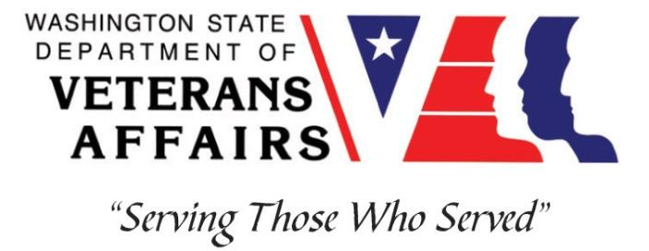
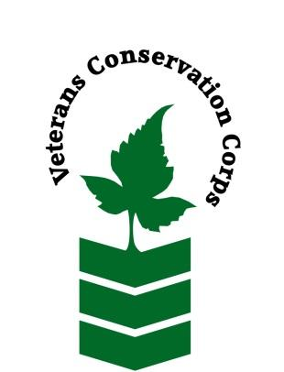
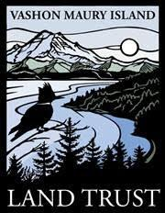
10014 SW Bank Rd, Vashon, WA 98070
(206) 463-2644
www.vashonlandtrust.org

Veterans Conservation Corps
with
Vashon Maury Island Land Trust
Matsuda Farm Internship

Program Overview

Matsuda Farm, a program of the Vashon Maury Island Land Trust (VMILT), was established in 2016 as a community farm, for the permanent protection and stewardship of farmland on Vashon Island. VMILT is a non-profit committed to conservation on Vashon Island, through such work as land acquisition and restoration, trail building and maintenance, outreach and education, and regenerative farming.

Position Summary

The Vashon-Maury Island Land Trust seeks an intern to assist with operations on our small-scale community farm. The work mainly consists of seeding, planting, weeding, and harvesting annual crops. The intern will also learn regenerative farming techniques and assist in the development of a holistic management plan and long-term vision for Matsuda Farm. The VCC intern will work closely with the farm manager, volunteer crews, the Land Trust team, as well as independently to accomplish organizational goals. This position is ideal for someone interested in sustainable agriculture and/or conservation work.

Schedule and Compensation

We work Monday through Friday from 8am to 4pm. This is a 6-month internship, with the possibility of extension, and includes a VCC stipend of $2400/month for a full-time internship (40 hours/week) or $1200/month for a part-time internship (20 hours/week) to help cover living expenses. In addition, VMILT will pay an additional stipend of $750 to augment higher costs of living on Vashon Island. Position has a flexible start date and will remain open until filled.

Essential Functions

Farm Production:

- Care for annual vegetable crops from seeding through transplanting, cultivation, and harvest in the field.
- Pack produce for sale following basic food safety guidelines.
- As needed, fill out invoice sheets and make deliveries.
- Based on interest, operate tractor for mowing and other farm tasks; learn to safely change out implements for use on front and back end.
- Set up, maintain, and operate the irrigation system.
- Participate in various building projects, including a picnic/gathering area.
- Carry out site maintenance such as mowing and weed whacking.
- Participate in volunteer work parties.
- Represent Vashon Land Trust to farm visitors and neighbors.

Other Duties:

- Participate in community outreach events and funding events as needed
- Other conservation program and administrative duties assigned by supervisor
- Other duties as assigned by supervisor

Requirements

- This position requires the applicant to be a veteran of the United States Uniformed Services to be eligible for this position
- Must have a valid driver’s license
- Ability to work independently in the field while demonstrating a strong work ethic and safety common sense
- Ability to work as part of a diverse team of staff and community volunteers in the field
- Ability to meet and work with new people
- Ability to act as a leader and uphold high ethical standards
- Excellent communication skills
- Excellent attention to detail
- Willingness to learn new skills
- Flexibility and a positive attitude

Preferred Knowledge, Skills, and Abilities

This is considered an entry level position and no experience is required, though an interest in farming is highly encouraged. Applicants with the following skills, knowledge, and abilities will be given preference:

  - First aid training
  - Experience with Microsoft Word

Physical Requirements

  - Physically able to conduct demanding field work in a variety of weather conditions
  - Ability to lift up to 50 pounds

Training

All necessary training required to perform the essential functions/duties is provided on the job.
In addition to on-the-job training, this position may include the following formal trainings and certifications to aid in personal & professional development:
- Posttraumatic Growth Training
- PTSD/TBI/Mental Health/ Suicide Awareness & Prevention
- Veteran Peer Support Training
- Environmental conservation conferences/symposiums/workshops
- Whole Farm Planning and Agricultural Entrepreneurship
- Other trainings/certifications as available and desired by intern

Apply

All applicants must pass a background check.

To apply, email a resume, a copy of your DD214 or service discharge certificate, a copy of your current driver’s license, and a cover letter explaining your interest in this internship to:

Kim Pham
Veterans Conservation Corps Program Manager
kim@dva.wa.gov

Questions?

To learn more about the Veterans Conservation Corps Internship Program, contact:

Kim Pham
Veterans Conservation Corps Program Manager
kim@dva.wa.gov

For more information about the Vashon Maury Island Land Trust and Matsuda Farm, contact:

Ryan Jones
Farm Manager, Matsuda Farm
Ryan@vashonlandtrust.org

