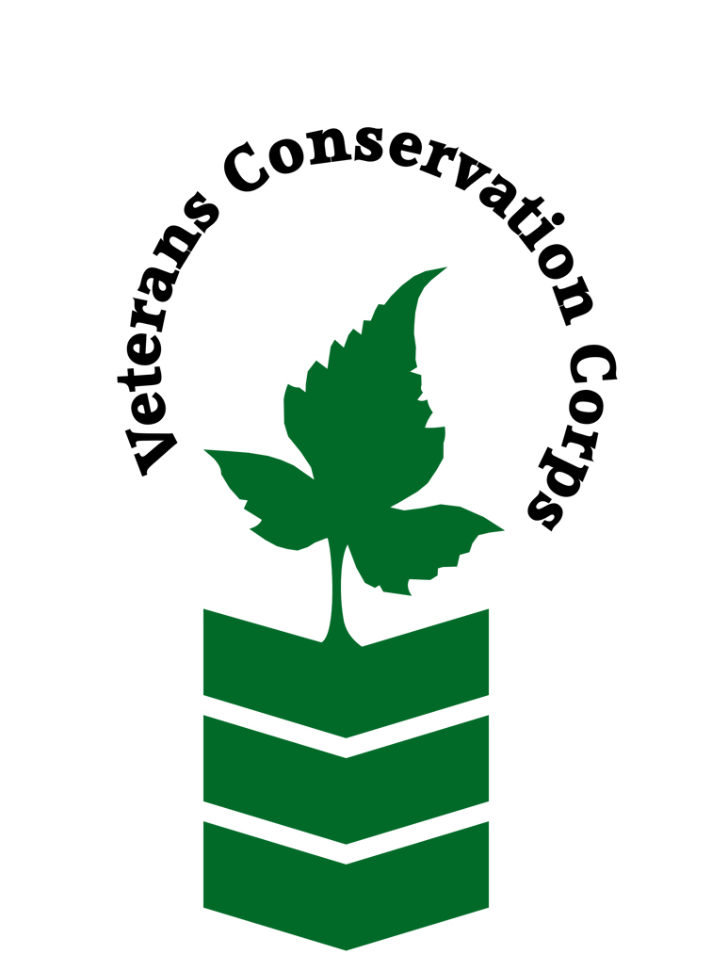
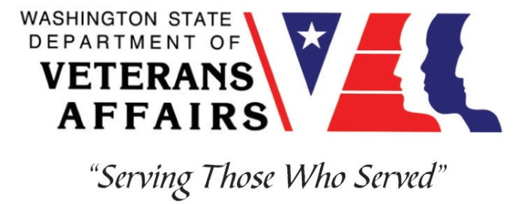
11700 Meadowmeer Circle NE, Bainbridge Island, WA 98110
www.biparks.org

Veterans Conservation Corps
with
Bainbridge Island Metro Park and Recreation District
Natural Resources Internship

***This position requires the applicant to be a veteran of the U.S. Uniformed Services***

Program Overview

For over 50 years, the Bainbridge Island Metro Park & Recreation District has served its community through stewardship of parks and formation of recreational and cultural programs for Islanders of all ages. The District manages over 1500 acres of land, over 40 miles of trails, and 75 acres of shoreline in service of their mission to build a healthy community through effective, sustainable stewardship of the District’s parks and open space, and through the development and delivery of innovative cultural and recreation opportunities. This position will work with the District’s Natural Resources Department to help manage natural spaces on Bainbridge Island.

Position Summary

Under general supervision, performs various duties related to trail construction and maintenance in parks and on Park District managed trails, invasive species removals, habitat restoration projects, and other duties as assigned. Work will involve primarily physical field work, using a variety of hand and power tools to build and maintain the Park District trail system to specified standards, and remove invasive species from District lands.

Examples of Duties and Responsibilities

- Assist with survey and control of noxious weeds and other invasive species.
- Operate and maintain equipment like GPS transmitters, backpack sprayers, vehicles, and various hand and power tools.
- Trail maintenance including vegetation removal, trail tread maintenance, spreading gravel and woodchips, and decommissioning unauthorized social trails.
- Trail building and reroutes like removing small trees and vegetation, establishing routes, and implementing best trail sustainability practices.
- Opportunity to work with community members through volunteer programs including monthly volunteer work parties, programing with school groups, and annual volunteer events.
- Opportunity to work with young people through Student Conservation Corps and Trails Crew, seasonal employment opportunities for 15-21 year olds.
- Opportunity to engage in the municipal planning process, working with staff to coordinate with local community groups like the Parks and Trails Foundation, City of Bainbridge Island, and more on park restoration and trail projects.
- Apply herbicides or other control measures to mitigate invasive species as directed by the Natural Resources Manager or their designee.
- Performs other duties and responsibilities as assigned by supervisor.

Schedule and Compensation

This 6-month internship begins April 2024 and includes a VCC stipend of $2400/month for a full-time internship (~40 hours/week) to help cover living expenses. Monday through Friday from 7:30 am – 4:00 pm. Alternative hours and flexible scheduling to meet the intern’s needs will be discussed on a case-by-case basis. Position open until filled.

Requirements

- This position requires the applicant to be a veteran of the United States Uniformed Services.
- Must have current valid Washington State driver’s license.

Preferred Qualities

Minimum qualifications are not established for this position; however, applicants with the following skills, knowledge, and abilities will be given preference:
- Good communication and writing skills.
- Experience in plant identification though on the job training is provided (native, non-native, and ornamental).
- Experience driving utility vehicles, equipment, and towing trailers.
- Experience with common landscape and forestry hand tools.
- Familiarity with Microsoft office programs (Word, Excel, PowerPoint, etc.).

Physical Requirements

- Comfortable working in remote settings, often independently.
- Capable of carrying up to 40 pounds.
- Ability to stand and/or walk for 8-hour shifts in challenging terrain and weather.
- Ability to use hand and power tools in a responsible manner.
- Ability to maintain a positive work environment and work harmoniously in a group.
- Ability and enthusiasm to learn new job-related skills.
- Ability to work independently without direct supervision.
- Ability to use time efficiently and effectively.
- Ability to interact with the public in a positive and courteous manner.
- Demonstrate punctual and reliable work habits.

Training

All necessary training required to perform the essential functions/duties is provided on the job.

In addition to on-the-job training, this position may include the following formal trainings and resources to aid in personal & professional development:
- Basic first aid, CPR, and safety training
- Native and invasive species identification training
- Veterans Cultural Engagement Training
- Posttraumatic Growth Training
- PTSD/TBI/Mental Health/ Suicide Awareness & Prevention
- Veteran Peer Support Training
- Environmental conservation conferences/symposiums/workshops
- Other trainings/certifications as available and desired by intern

Apply

To apply, email a resume, a copy of your DD214 or service discharge certificate, a copy of your current driver’s license, and a cover letter explaining your interest in this internship to:

Kim Pham
Veterans Conservation Corps Program Manager
kim@dva.wa.gov

Questions?

To learn more about the Veterans Conservation Corps, contact:

Kim Pham
Veterans Conservation Corps Program Manager
kim@dva.wa.gov

For more information about the BI Metro Park and Recreation’s internship, contact:

Morgan Houk
Program Manager
morganhouk@biparks.org
206-502-3229

Lydia Roush
Natural Resources Manager
lydiar@biparks.org
206-825-9602

