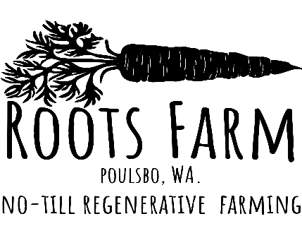
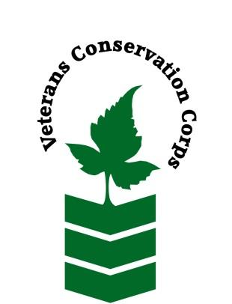
00
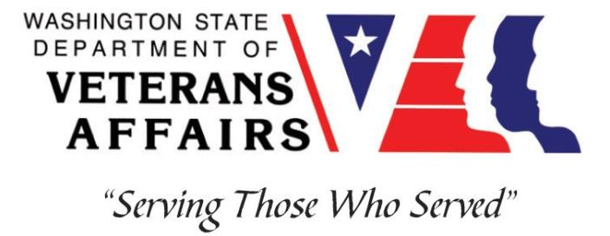

www.rootsfarmwa.com

Veterans Conservation Corps
with
Roots Farm
Farm Internship

Program Overview

At Roots Farm, our mission is to ensure equitable food access in our community through food distribution to local food banks and partnering with local businesses to offer free classes that teach and empower community members to grow and prepare their own healthy foods. Our farm also sells at the Poulsbo Farmers Market every Saturday, and we have a small weekly farm share. We also grow mushrooms, keep goats, sheep, pigs, and various types of poultry.

Our growing practices are grounded in principles of environmental sensitivity. With a changing climate, we must employ sustainable growing practices that sequester carbon, improve soil, and conserve water. Our farm relies on wood chips, a recycled industry byproduct, as a mulch source. This sustainable soil conservation method reduces water and fertilizer usage while promoting healthy soil biology. Currently, we spread all chips by hand with a pitchfork, rake, and push wagon to avoid the use of fossil fuel-powered implements. We also utilize recycled brown cardboard and coffee sacks on the farm as weed blocks. We do not use any chemical fertilizers or pesticides and strive to grow the cleanest and most nutrient-dense produce as possible.

Our goal in 2024 is to make 100% of our farm inputs sustainably. We rescue produce from food banks and an organic food company that is fed to worms, turned into vermicompost, turned into Bokashi compost, and fed to our livestock, whose manure can be composted. We also re-ceive fish waste from our local tribe that we have turned into fish emulsion, as well as imple-ment Korean natural farming and jadam practices that promote making our own on-farm inputs. We are currently leading a research study to analyze the use of bokashi and biochar in field vegetable production, in which we will be analyzing plant growth, soil nutrient levels, and biological activity.

Roots Farm also participates in the WSU Farm Mentor Program, which is a collaborative effort among Kitsap County farms to offer farm interns educational opportunities. Each participating farm will offer classes on varying topics throughout the season, and Roots Farm interns can attend all classes and activities offered through this program.
At Roots Farm, we strive to create a positive working environment, friendships, and a deeper connection to our community and environment. We look forward to working with you!

Position Summary

As a VCC intern, you will be the spearhead of all things farm-related at Roots Farm in Poulsbo. You will work alongside the farm owner, Jennifer Clark, and her crew to assist in carrying out a myriad of different farm tasks. The intern will be introduced to small-scale no-till regenerative farming, livestock management, greenhouse management, and community building, all with a focus on regenerative practices and equitable food access and education.

Responsibilities may include:

- Assist in no-till farming practices such as laying biodegradable wood blocks and spreading compost and woodchips
- Greenhouse seeding and plant propagation
- Irrigation management
- Weed management
- Harvesting
- Post-harvest: washing and packaging produce
- Field seeding and transplanting: direct seeding crops using Jang seeder and hand transplanting green house starts
- Bed and field preparation: raking, digging, weeding, crop residue cleanup, bed tarping, digging trenches, spreading liquid and dry fertilizers
- Compost management: vermincompost feeding and management, trench composting, bokashi bin maintenance, compost sifting
- Infrastructure management: trellis set-up, setting up hoops and weed blocks, laying silage tarps, greenhouse plastic installation
- Farm maintenance: debris cleanup, weed whacking, and mowing
- Assist in organic pest management controls
- Produce delivery
- Class and workshop set-up and implementation
- Research study data collection

Schedule and Compensation

This is a 6-month internship, with the possibility of extension, and includes a VCC stipend of $2400/month for a full-time internship (40 hours/week) to help cover living expenses. We work Monday through Friday from 8am to 4pm, with some schedule flexibility. Assistance could be needed on a few Saturdays which can be exchanged for a weekday - not required but appreciated! Position has a flexible start date and will remain open until filled.

Requirements

- This position requires the applicant to be a veteran of the United States Uniformed Services to be eligible for this position
  - Must be able to complete tasks independently with minimal supervision
  - Must be able to follow directions and complete tasks in an efficient manner
  - Must possess a positive attitude and willingness to learn new skills!
  - Must have excellent communication skills
  - Ability to work well with others

Physical Requirements

  - Must be willing to work in inclement weather conditions—hot, cold, and rainy weather!
  - Must be able to lift 50 lbs.
  - Must be able to perform farm tasks that require bending, lifting, working on hands and knees, digging, raking, walking hilly terrain, and pushing wheelbarrows or carts

Training

All necessary training required to perform the essential functions/duties is provided on the job.
In addition to on-the-job training, this position may include the following formal trainings and certifications to aid in personal & professional development:

- WSU Farm Mentor classes and activities
- Tilth Conference
- Posttraumatic Growth Training
- PTSD/TBI/Mental Health/ Suicide Awareness & Prevention
- Veteran Peer Support Training
- Environmental conservation conferences/symposiums/workshops
- Whole Farm Planning and Agricultural Entrepreneurship
- Other trainings/certifications as available and desired by intern

Apply

All applicants must pass a background check.

To apply, email a resume, a copy of your DD214 or service discharge certificate, a copy of your current driver’s license, and a cover letter explaining your interest in this internship to:

Kim Pham
Veterans Conservation Corps Program Manager
kim@dva.wa.gov

Questions?

To learn more about the Veterans Conservation Corps Internship Program, contact:

Kim Pham
Veterans Conservation Corps Program Manager
kim@dva.wa.gov

For more information about Roots Farm, contact:

Jennifer Clark
Farm Manager
rootsfarmwa@gmail.com

