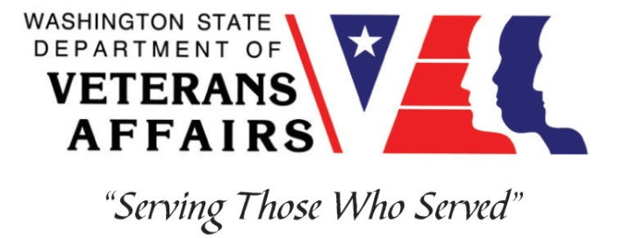
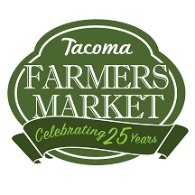

Veterans Conservation Corps
Tacoma Farmers Market Internship

Overview

The Tacoma Farmers Market creates vibrant marketplaces where local farms, small businesses, and organizations connect directly with the community. TFM is a 501c (4) nonprofit organization operating four farmers markets in the Tacoma metropolitan area, celebrating our 29th year in Tacoma in 2019. The staff at TFM includes a full time Executive Director and Operations Director, part time Bookkeeper, and seasonal employees. Learn more about TFM at http://tacomafarmersmarket.com.

In pursuit of our mission and with recognition of historical and present-day racism and inequity in our food system, the Tacoma Farmers Market is committed to diversity, equity, and inclusion as core values. We are an Equal Opportunity Employer and welcome applications from individuals without regard to race, color, religion (creed), gender, gender expression, age, national origin (ancestry), disability, marital status, sexual orientation, or military status. TFM prohibits any form of workplace harassment including harassment on our marketplaces. We seek to build and support a just food system in our community.

Position Summary

The Seasonal Market Intern reports to the Operations Director (OD) and will assist the OD and Market Manager (MM) on market days to ensure the success of all three farmers markets. Our seasonal market staff are integral to the running of our markets and will be involved in most aspects of day to day market operations. The intern will play a critical role in market set-up and break-down, customer service for market shoppers and vendors, and ensuring an inclusive and welcoming environment for our food access program users. This position is part of a team responsible for the cleanliness, safety, and positive atmosphere of our markets.

This position also offers an intern the opportunity to work directly with our farms and other vendors, building relationships with the market community and gaining experience with small, local businesses.

Hours and Compensation
The Seasonal Market Internship is a full-time (up to 40 hours/week), seasonal position. This is a 6-month internship that will begin April 27, 2020, and includes a stipend of $1800/month to help cover living expenses. Candidate must be available for at least two of the following three days: Tuesdays, Thursdays, and Sundays. TFM will provide a small monthly food stipend during market season as well as some TFM merchandise.

Responsibilities
General Operations & Equipment
- Set up, tear down, and care for market equipment
- Work with MM to ensure complete and correct market set up each week, including TFM equipment as well as vendor and community booths
- Identify and take steps to appropriately deal with hazards to ensure shopper and vendor safety
- Assure the market area is clean throughout the day and at the end of market
- Ensure markets are ready to open at the appropriate hour
- Assist market staff as needed

Vendors
- Work with OD and MM to identify and pursue educational opportunities with our vendors
- Be familiar with market rules and guidelines and be able to communicate them politely and effectively
- Build and maintain relationships with vendors
- Perform traffic control on the marketplace as needed

Administration/Information Booth Activities
- Help create an inclusive environment at our markets by providing highest level of customer service to vendors and shoppers
- Run credit, debit and EBT transactions for the purchase of market tokens and merchandise
- Assist with TFM food access projects such as Apple A Day, Fresh Bucks, and other matching and incentive programs
- Communicate updates, changes, and issues regularly to MM and OD
- Set up and assist with chef demonstrations, youth activities, and other market events
- Assist with vendor envelope distribution and collection and WIC program checks as needed
- Vendor fee envelope preparation, distribution and collection

Market Development
- Support local markets through distribution of information to local businesses and community partners
- Be an active team member by working closely with staff to communicate ideas, identify potential problems, provide feedback, and offer creative solutions
- Attend weekly staff meetings

Additional Perks:
- You get to work with a fabulous team at a well-respected organization
- The markets are a ton of fun
- You’ll be outside all summer
- The market swag is fab – t-shirt and sweatshirt for all market staff
- The FOOD! You will be surrounded by the freshest, tastiest, healthiest food in town

Requirements
- Must be a United States military veteran
- Must have the capacity to work efficiently alone and in a team
- Must be able to lift 40 lbs or more
- Must have a valid driver’s license
- The successful candidate possesses:
  - Strong customer service and people skills
  - Ability to work and think under time pressures
  - Willingness and skill to give and receive feedback
  - A passion for local agriculture, small business, and community food systems
  - A great sense of humor is also a plus

Training
All necessary training required to perform the essential functions/duties is provided on the job.

In addition to on-the-job training, this position may include the following formal trainings and certifications to aid in personal & professional development:

- CPR/First Aid
- Posttraumatic Growth Training
- PTSD/TBI/Mental Health/ Suicide Awareness & Prevention
- WDVA Veteran Peer Corps Certification
- VCC Annual Retreat and Training
- Resume/cover letter/job interviews

Apply

All applicants must pass a background check.

To apply, email a resume, a copy of your DD214, a copy of your current driver’s license, and a cover letter explaining your interest in this internship to:

Kim Pham
Veterans Conservation Corps Program Specialist
kim@dva.wa.gov

Questions?
To learn more about the Veterans Conservation Corps, contact:

Kim Pham
Veterans Conservation Corps Program Specialist
kim@dva.wa.gov

For more information about the Tacoma Farmers Market contact:

Anika Moran
Executive Director
Tacoma Farmers Market
anika@tacomafarmersmarket.com

