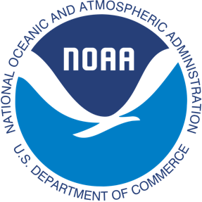
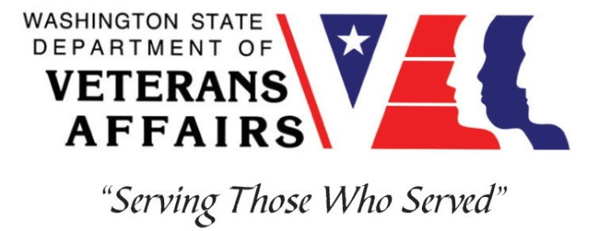
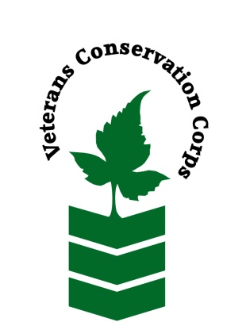
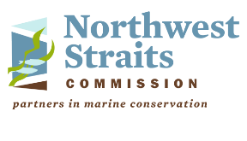

Northwest Straits Commission, 10441 Bayview-Edison Rd, Mount Vernon, WA 98273
https://nwstraits.org/

NOAA WDVA Veterans Conservation Corps Fisheries Internship Program
with the
Northwest Straits Commission

***This position requires the applicant to be a United States military veteran***

Program Description
The NOAA WDVA Veterans Conservation Corps Fisheries Internship Program is a Washington-based internship focused on marine science and stewardship of coastal resources. Since 2016, NOAA has been funding these internships and partnering with the WDVA Veterans Conservation Corps to deliver high level science-based experiences at NOAA Research Centers and NOAA partner organizations throughout Washington. This internship adds the Northwest Straits Commission to this NOAA and WDVA Veterans Conservation Corps partnership. The internship will be supervised by the Northwest Straits Commission and located at their facilities, with coordination and support provided by the VCC and NOAA.

General Description
This position is with the Northwest Straits Commission (NWSC) (https://nwstraits.org/) housed at the Padilla Bay National Estuarine Research Reserve in Mount Vernon, WA. The project is focused on trapping and removal of the highly invasive European green crab (EGC) in Drayton Harbor in Blaine, WA. While the trapping season, which extends through the end of October, is entirely field-based, there may be additional in-office opportunities in the month of November 2020 to assist with data reporting, processing and communicating results.

Position Description
As part of the EGC trapping team, the intern will have the opportunity to contribute to a community based effort to protect native species and habitat from an invasive threat. The intern will learn invasive species control strategies, native species identification and community approaches to conservation.

EGC are among the top 100 most invasive species in the world and are listed as a tier 1 (highest threat) invasive species by the WA Dept. of Fish and Wildlife for their threat to native ecosystems, the economy and cultures of the region. They were first identified in Puget Sound in 2016 and since that time, Drayton Harbor has been identified as a priority site due to a high density of EGC settlement. EGC cause irreparable harm to eelgrass beds, marshes and predate on native shellfish. Trapping and removal is the most effective means of preventing EGC establishment in Puget Sound.
EGC trapping and removal will include trap placement, EGC and native species identification and field data recording. The NWSC collaborates with technical experts from the WA Dept. of Fish and Wildlife, WA Sea Grant and local volunteers to accomplish this work. Travel to the trapping location is required.

There are also anticipated to be additional opportunities to network and communicate with NOAA research staff and communicate the results and experiences of this internship.

This 3-month internship includes a stipend of $900/month for a part-time internship (approximately 20 hours/week) or $1800/month for a full-time internship (approximately 40 hours/week) to help cover living expenses. There is a possibility that this internship may be extended.

Schedule:

The schedule for this project is highly variable, tide dependent and varies each week Monday – Friday. Some weekend work may occur to take advantage of favorable tides. Trapping will generally occur an average of two days per week, 8 – 10 hours per day. During some weeks, trapping will not occur while other weeks may consist of five days as tides allow.

Required Skills, Knowledge, and Abilities

- This position requires the applicant to be a United States military veteran.

Preferred Qualities
Minimum qualifications are not established for this position; however, applicants with the following skills, knowledge, and abilities will be given preference.
- Motivated and enthusiastic, with an interest in marine biology
- Interest and willingness to work with volunteers
- Ability to work independently and as a member of a small crew
- Strong self-initiative, and good attention to detail
- Experience with MS Word, Excel, Access and PowerPoint
- Familiarity with the Pacific Northwest marine environment, marine fishes and nearshore organisms of Washington waters is preferred
- Follows appropriate safety practices in the field

Physical Requirements:

- Ability to traverse difficult terrain including steep embankments and deep mud flats while manually transporting heavy traps
- Ability to work outdoors in any weather condition

Training
All necessary training required to perform the essential functions/duties is provided on the job.

In addition to on-the-job training, this position may include the following formal trainings and certifications to aid in professional development and job training:
- CPR/First Aid
- Posttraumatic Growth Training
- PTSD/TBI/Mental Health/ Suicide Awareness & Prevention
- WDVA Veteran Peer Corps Certification
- Vet Corps Annual Training (every August)
- Vet Corps Mid-year Training (every February)
- Resume/cover letter/job interviews

Apply
All applicants must pass a background check.

To apply, email a resume, a copy of your DD214, a copy of your current driver’s license, and a cover letter explaining your interest in this internship to:

Kim Pham
Veterans Conservation Corps Program Specialist
kim@dva.wa.gov

Questions?
To learn more about the NOAA WDVA Veterans Conservation Corps Fisheries Internship Program, contact:

Kim Pham
WDVA
Veterans Conservation Corps Program Specialist
kim@dva.wa.gov

John Floberg
NOAA
Marine Habitat Resource Specialist
John.r.floberg@noaa.gov

For more information about NWSC, contact:

Lucas Hart
Executive Director
Northwest Straits Commission
hart@nwstraits.org
360-391-7190

