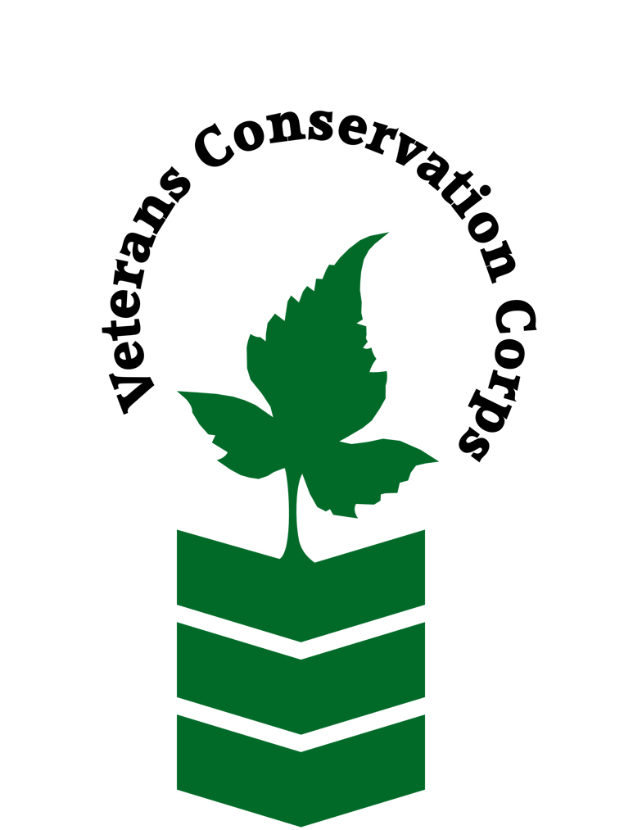
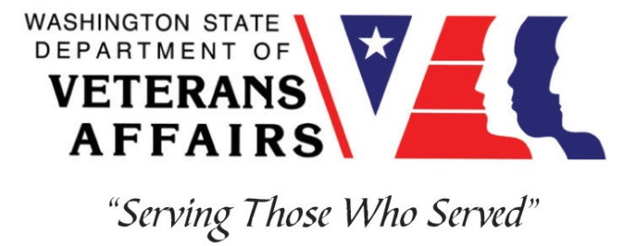
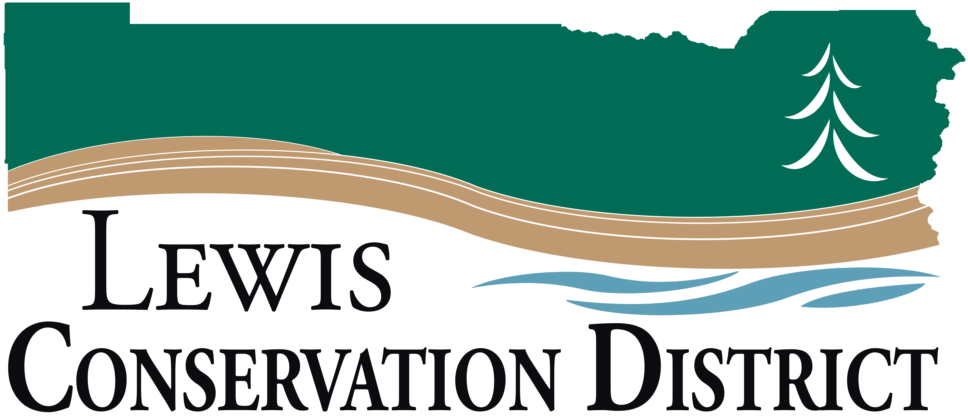

2057 SW Salsbury Ave.
Chehalis, WA 98532
(360) 996-4560
https://lewisconservation.wordpress.com

Veterans Conservation Corps Internship Program
with
Lewis Conservation District

General Description

The Lewis Conservation District (LCD) is a non-regulatory local agency that works with landowners to help resolve their natural resource issues on their land. The LCD provides programs and technical assistance to implement conservation practices that benefit soil, water, and wildlife. As an intern with LCD, you will work closely with staff to conduct surveys to determine landowner willingness to complete habitat improvement projects and noxious weed control. You will have the opportunity to learn about fish passage improvement projects, riparian plantings, farm planning, and other District programs.

Position Description

The candidate will:

- Assist with landowner surveys for habitat improvement projects.
- Help implement the Voluntary Stewardship Program (VSP) through landowner surveys and mailings.
- Assist with tree planting, establishment, and maintenance.
- Assist with noxious weed surveys and follow-up control.
- Learn the steps of the farm planning process and assist with site visits to identify resource concerns.
- Assist with District equipment rentals and soil samples.
- Have the opportunity to pursue special interest projects as time and resources allow.
- Perform any and all related duties that advance the mission and purposes of LCD.

Schedule and Compensation:

This 6-month internship will begin in April 2021, and includes a VCC stipend of $900/month for a part-time internship (~20 hours/week) to help cover living expenses.

A typical work week will be two 10-hour days between Monday-Thursday from 7:30 am to 6:00 pm. Work days and times may change to accommodate project needs and seasons. There may be some weekend opportunities. Alternative hours and flexible scheduling to meet the intern’s needs will be discussed on a case-by-case basis.

Requirements
- Must be a United States military veteran to be eligible for this position
- Must have dependable transportation to and from the Lewis Conservation District office
- Must be able to work Monday-Thursday.

Preferred Knowledge, Skills, and Abilities
This is considered an entry level position and no experience is required. Applicants with the following skills, knowledge, and abilities will be given preference:

- Currently possess or be able to obtain a valid driver’s license
- Experience implementing safety practices in the field with and without supervision
- Able to work outside in inclement weather conditions
- Able to take direction and work as a member of a team
- Motivated and enthusiastic
- Excellent attention to detail
- Comfortable speaking to landowners and other members of the public about projects
- Basic computer skills and data entry skills (Microsoft Word and Excel)

Training
All necessary training required to perform the essential functions/duties is provided on the job.

In addition to on-the-job training, this position may include the following formal trainings and certifications to aid in personal & professional development:

- Veterans Cultural Competency Training
- CPR/First Aid
- Posttraumatic Growth Training
- PTSD/TBI/Mental Health/ Suicide Awareness & Prevention
- WDVA Veteran Peer Corps Certification
- VCC Annual Training (every August)
- Environmental conservation conferences/symposiums/workshops
- Growing your veteran-owned small business
- Whole Farm Planning and Agricultural Entrepreneurship
- Other trainings/certifications as available and desired by intern
Apply

All applicants must pass a background check.

To apply, email a resume, a copy of your DD214, a copy of your current driver’s license, and a cover letter explaining your interest in this internship to:

Kim Pham
Veterans Conservation Corps Program Specialist
kim@dva.wa.gov

Questions?

To learn more about the Veterans Conservation Corps, contact:

Kim Pham
Veterans Conservation Corps Program Specialist
kim@dva.wa.gov

For more information about Lewis Conservation District:

Kenna Fosnacht
Resource Technician
Kenna.Fosnacht@lewiscdwa.com
(360) 996-4560
https://lewisconservation.wordpress.com

