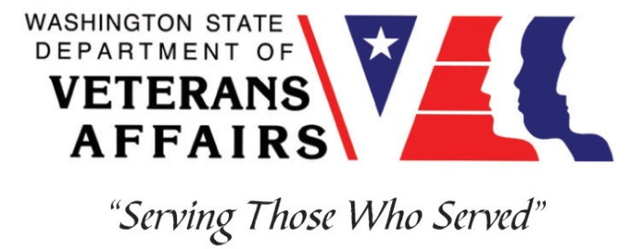
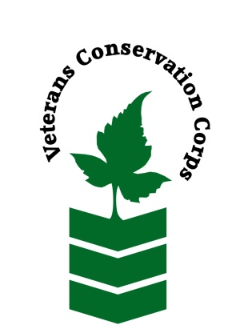
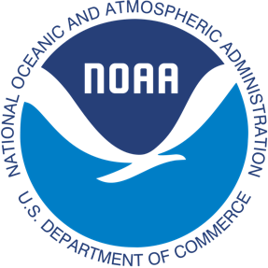
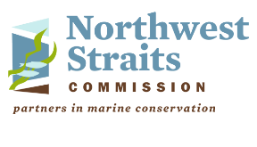

Northwest Straits Commission, 10441 Bayview-Edison Rd, Mount Vernon, WA 98273
https://nwstraits.org/
NOAA WDVA Veterans Conservation Corps Fisheries Internship Program
with the
Northwest Straits Commission

***This position requires the applicant to be a United States military veteran***

Program Description
The NOAA WDVA Veterans Conservation Corps Fisheries Internship Program is a Washington-based internship focused on marine science and stewardship of coastal resources. Since 2016, NOAA has been funding these internships and partnering with the WDVA Veterans Conservation Corps to deliver high level science-based experiences at NOAA Research Centers and NOAA partner organizations throughout Washington. This internship adds the Northwest Straits Commission to this NOAA and WDVA Veterans Conservation Corps partnership. The internship will be supervised by the Northwest Straits Commission. The intern will have the opportunity to work in the field, from home, and at Northwest Straits Commission facilities, with coordination and support provided by the VCC and NOAA.

General Description
This position is with the Northwest Straits Commission (NWSC) (https://nwstraits.org/) housed at the Padilla Bay National Estuarine Research Reserve (NERR) in Mount Vernon, WA. The Northwest Straits Commission mission is to protect and restore the marine waters, habitats and species of the Northwest Straits region to achieve ecosystem health and sustainable resource use. The mission is achieved by providing coordination, technical, and funding support to local volunteer based Marine Resources Committees in seven counties of North Puget Sound. Northwest Straits Commission staff also strive to connect Marine Resources Committee (MRC) priorities with regional efforts to protect and restore Puget Sound through collaborative conservation. Staff perform their duties from home and in the field with periodic in-person meetings at the Northwest Straits Commission offices located at the Padilla Bay NERR.

Aspects of this internship will depend upon the status of COVID-19. In particular, the ability to work directly with individuals in the field and in office settings may be limited until public safety can be assured. In the interim, meetings will be held virtually or with small groups outdoors while implementing proper safety procedures.

Position Description
This position will work collaboratively with NWSC staff, volunteers, and partners. Tasks will include both field and office work. The intern will have the opportunity to contribute to a community-based effort to establish voluntary no-anchor zones for eelgrass protection, protect native species and habitat from green crab, assist with data management for volunteer bull kelp monitoring, and participate in community-based symposiums and board meetings. The intern will learn strategies for natural resource protection through community engagement approaches.

Eelgrass is recognized as important habitat that supports key species of Puget Sound such as Dungeness crab, salmon, and forage fish. Boat anchoring is one of the biggest threats to healthy eelgrass habitat. Jefferson County MRC established and maintains voluntary no-anchor zones to protect eelgrass against damage caused by anchoring. The NWSC aims to expand this community-driven initiative to additional counties in North Puget Sound. This position will play a pivotal role in helping to build a regional project in its early development.

Green crab are among the top 100 most invasive species in the world and pose an emerging threat to eelgrass and native shellfish. In 2020, the NWSC developed a partnership with the WA Dept. of Fish and Wildlife and WA Sea Grant to trap and remove green crab from Drayton Harbor, located in Whatcom County. This position will work alongside multiple partners to trap and remove green crab, while also developing community support and collaboration for prolonged program success.

Like eelgrass, kelp provides important habitat to numerous species in Puget Sound. Due to many stressors, kelp is declining in areas of Puget Sound. The NWSC leads a volunteer-based kelp monitoring program to understand the long-term changes in kelp coverage. Opportunities to support this program include data management and processing. Additional tasks may include creating data products and reports for the volunteers and broader community on status and trends of local kelp.

This position’s tasks may include:
- Conducting eelgrass protection zone site assessments and developing project partner lists in partnership with MRCs. For example, collecting information on environmental conditions and scoping project partner opportunities for each proposed site, developing standard monitoring protocols and datasheets for intern and volunteer use, and training volunteers on monitoring methods.
- Trap placement, species identification and field data recording for green crab removal.
- Assisting with green crab landowner and community education and outreach.
- Kelp monitoring data management and processing.
- NWSC project database data entry.
- Assisting with project meeting and workshop notetaking and summaries.
- Collaboration with technical experts from the WA Dept. of Fish and Wildlife, WA Dept. of Natural Resources, WA Sea Grant, local volunteers, and other partners.
- Reporting on project progress to the NWSC Board.

Travel to project site locations is required.

There are also anticipated to be additional opportunities to network and communicate with NOAA research staff and communicate the results and experiences of this internship.

This 6-month internship includes a stipend of $900/month for a part-time internship (approximately 20 hours/week) or $1,800/month for a full-time internship (approximately 40 hours/week) to help cover living expenses. There is a possibility that this internship may be extended to November 30, 2021.

Schedule:

This internship will be available April 1, 2021 – September 30, 2021 with the possibility of extension to November 30, 2021. The schedule is generally Monday through Friday 9-5. Green crab trapping is tide dependent and varies each week. Some weekend work may occur to take advantage of favorable tides. Green crab trapping will generally occur an average of two days per week, 8 – 10 hours per day. Extended field days will not exceed 40 hours per week. Eelgrass, kelp and other tasks will be scheduled when tides do not favor green crab trapping. Alternative hours and flexible scheduling to meet the intern’s needs will be discussed on a case-by-case basis.

Required Skills, Knowledge, and Abilities

- This position requires the applicant to be a United States military veteran.

Preferred Qualities
Minimum qualifications are not established for this position; however, applicants with the following skills, knowledge, and abilities will be given preference.
- Motivated and enthusiastic, with an interest in marine biology
- Interest and willingness to work with volunteers
- Ability to work independently and as a member of a small crew
- Strong self-initiative, and good attention to detail
- Experience with MS Word, Excel, Access and PowerPoint
- Familiarity with the Pacific Northwest marine environment, marine fishes and nearshore organisms of Washington waters is preferred
- Follows appropriate safety practices in the field

Physical Requirements:

- Ability to traverse difficult terrain including steep embankments and deep mud flats while manually transporting heavy traps
- Ability to work outdoors in any weather condition

Training
All necessary training required to perform the essential functions/duties is provided on the job.

In addition to on-the-job training, this position may include the following formal trainings and certifications to aid in professional development and job training:
- CPR/First Aid
- Posttraumatic Growth Training
- PTSD/TBI/Mental Health/ Suicide Awareness & Prevention
- WDVA Veteran Peer Corps Certification
- Vet Corps Annual Training (every August)
- Vet Corps Mid-year Training (every February)
- Resume/cover letter/job interviews

Apply
All applicants must pass a background check.

To apply, email a resume, a copy of your DD214, a copy of your current driver’s license, and a cover letter explaining your interest in this internship to:

Kim Pham
Veterans Conservation Corps Program Specialist
kim@dva.wa.gov

Questions?
To learn more about the NOAA WDVA Veterans Conservation Corps Fisheries Internship Program, contact:

Kim Pham
WDVA
Veterans Conservation Corps Program Specialist
kim@dva.wa.gov

John Floberg
NOAA
Marine Habitat Resource Specialist
John.r.floberg@noaa.gov

For more information about NWSC, contact:

Lucas Hart
Executive Director
Northwest Straits Commission
hart@nwstraits.org
360-391-7190

