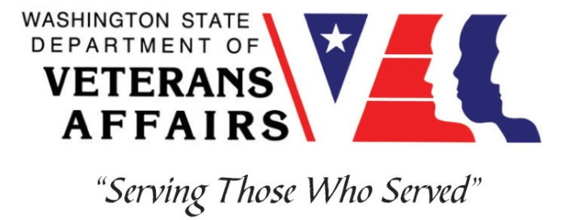
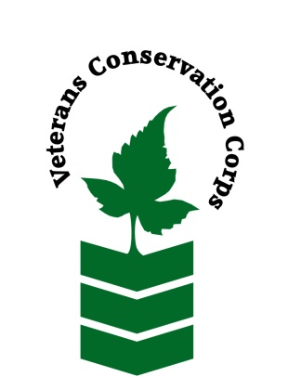
15208 102nd St E, Puyallup, WA 98374
(253) 584-1040
https://efoodnet.org/get-involved/farm/

Veterans Conservation Corps
with
Mother Earth Farm
Farm Internship

Overview
Our Story: Emergency Food Network is located in Lakewood, WA and was established in 1982. In a given year we move over 14 million pounds of food and serve more than 71 partner programs. Our Board of Directors is active and engaged and we also have an Ambassador Board. EFN also operates Mother Earth Farm, an 8-acre farm in the Puyallup River Valley to meet the need for fresh food in the community. Each year, Mother Earth Farm uses organic practices to grow over 100,000 pounds of fruits and vegetables a year for our partners.

Mostly focused on vegetables, Mother Earth also has an orchard, beehives, and flower garden. We grow and harvest throughout the year, using two high tunnels and three caterpillar tunnels over the winter. Historically, Mother Earth Farm has worked closely on all farm tasks with a crew of incarcerated people from the Washington Correctional Center for Women in Gig Harbor as an educational and re-entry program. The farm also relies on the work of farm assistants, interns, and volunteers from our surrounding community.

Position Summary
The candidate will be introduced to small-scale non-profit farming, greenhouse management, and food insecurity issues, and may have the opportunity to pursue special interest projects as time and resources allow.

Hours and Compensation
This internship will begin April 2021 and continue through September 30, 2021, with the possibility of extension to November 30, 2021. It will require approximately 40 hours per week, and includes a stipend of $1800/month to help cover living expenses. Schedule will be Mon-Fri 8 am - 4 pm, with some possible weekend hours. Schedule can be adapted on a case by case basis.
Responsibilities
- Implement daily directives of the Farm Manager or Assistant Manager
- Carry out all aspects of organic fruit and vegetable production including seeding, cultivating, transplanting, and weeding
- Lead tours describing the Emergency Food Network and Mother Earth Farm’s mission, practices, and work in the community
- Maintain and operate a drip irrigation system
- Train, lead, and work with groups of volunteers, including youth, with the supervision of farm management
- Work alongside a diverse crew of farm laborers while maintaining professional boundaries
- Other general manual labor as assigned

Requirements
- Must be a United States military veteran
- Have a valid driver’s license
- Candidate must be able to complete tasks independently with minimal supervision
- Take directions and complete a task on time
- Must be proficient in or willing to learn to operate:
  - Truck
  - Tractor
  - Power hand tools and other farm equipment and implements
- Physically work long hours in hot or inclement weather with the possibility of bugs, ticks, snakes, or other critters
- Work alongside a diverse crew of farm labors while maintaining professional boundaries
- The successful candidate possesses:
  - Knowledge and experience in basic equipment operation and maintenance
  - Commitment to high quality work relationships

Training
All necessary training required to perform the essential functions/duties is provided on the job.

In addition to on-the-job training, this position may include the following formal trainings and certifications to aid in personal & professional development:

- Veterans Cultural Competency Training
- CPR/First Aid
- Posttraumatic Growth Training
- PTSD/TBI/Mental Health/ Suicide Awareness & Prevention
- WDVA Veteran Peer Corps Certification
- VCC Annual Training (every August)
- Environmental conservation conferences/symposiums/workshops
- Growing your veteran-owned small business
- Whole Farm Planning and Agricultural Entrepreneurship
- Other trainings/certifications as available and desired by intern

Apply

All applicants must pass a background check.

To apply, email a resume, a copy of your DD214, a copy of your current driver’s license, and a cover letter explaining your interest in this internship to:

Kim Pham
Veterans Conservation Corps Program Specialist
kim@dva.wa.gov

Questions?

To learn more about the Veterans Conservation Corps, contact:

Kim Pham
Veterans Conservation Corps Program Specialist
kim@dva.wa.gov

For more information about Mother Earth Farm contact:

Liam McNamara
Farm Manager
liamm@efoodnet.org

