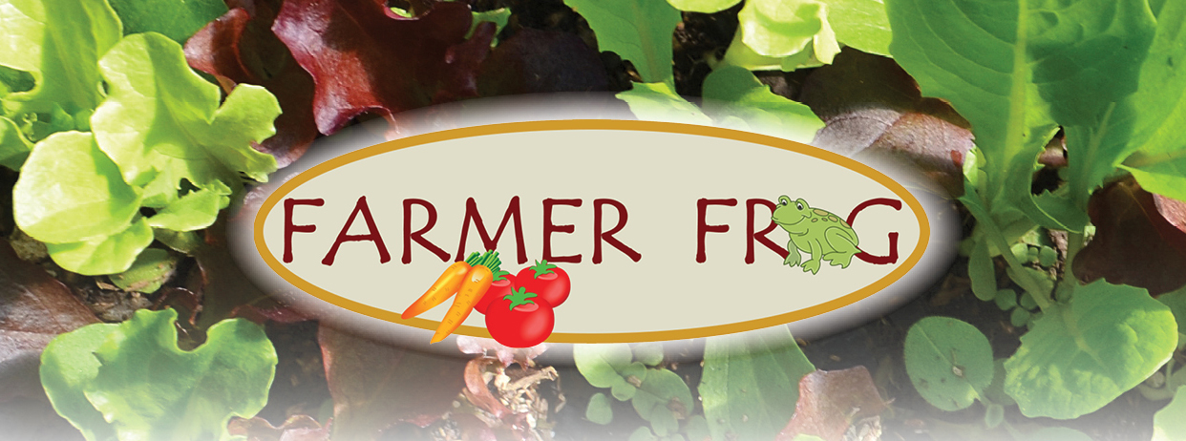
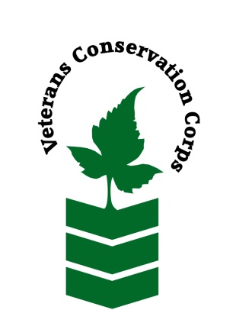
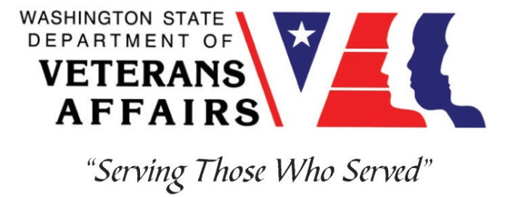
23210 Paradise Lake Rd
Woodinville, WA 98077
www.farmerfrog.org / (425) 210-5541

Veterans Conservation Corps
with
Farmer Frog Farm
Farm Internship

Overview
Our Story: Farmer Frog is an educational edible school garden management and food sharing program. Paradise Farm is our HQ facility, a hands-on learning center where students of all ages learn STEAM through permaculture farming and ecosystem restoration.
Paradise Farm is a permaculture-based operation. We use non-lethal wildlife deterrent practices to manage the critters living in the 840 acres of forest surrounding the farm. We are Salmon Safe, Wildlife Friendly, and Wildlife Wise Certified. We have orchards that are sylvo-pastured using poultry such as geese, ducks, turkeys, guineas, chickens and more. We have sheep, goats, bees, and livestock guardian dogs. We also have worm bins and fish in our aquaponic systems. We combine 21st Century technology with ancient practices.
We grow and harvest throughout the year with our 8 permanent hoop houses. The farm is managed by our volunteers and paid staff, farm managers and livestock team, interns, and volunteers from the community.
Recently, as a response to the COVID-crisis, we refocused to supply a large volume of food to the region’s food banks, community organizations, and meal programs. In 20 months we moved over 130 million pounds of food to over three million people in 36 states.

Position Summary
The candidate will be introduced to small-scale non-profit farming, livestock management, greenhouse management, food system issues and potentials for resiliency. We are hoping interns will focus on livestock management since that is one of the largest portions of our work. During COVID outbreaks and intense surges interns can participate in our COVID monitoring and management programs as well.

Hours and Compensation
This 6-month internship will begin March 2022, with the possibility of an extension. Includes a monthly stipend to assist with living expenses: $1800 for a full-time internship (approx. 40 hrs/week) and $900 for a part-time internship (approx. 20 hrs/week). Position open until filled.

Responsibilities
- Implement daily directives of the Farm/Livestock Managers
- Carry out all aspects of sustainable free-range pasture-based livestock farming; have a basic understanding of the overall workings of the farm including vegetable and fruit production
- Lead tours describing the Farm’s mission, practices, and work in the community
- Maintain and operate various irrigation systems
- Depending on the COVID situation and day-to-day changes of the local regulations related to the crisis, train, lead, and work with groups of volunteers, including youth, with the supervision of farm management
- Work alongside diverse farm crews while maintaining professional boundaries
- Other general manual labor as assigned

Requirements

*During the COVID outbreak we require all folks to wear a mask that covers both the nose and mouth, wear work gloves, and maintain appropriate social distancing

- Must be a veteran of one of the United States uniformed services
- Have a valid driver’s license
- Candidate must be able to complete tasks independently with minimal supervision
- Take directions and complete tasks on time
- Must be proficient in or willing to learn to operate:
  - Truck not requiring a CDL
  - Tractor, bobcat, ATV
  - Power hand tools and other farm equipment and implements
- Physically work long hours in hot or inclement weather with the possibility of bugs, ticks, snakes, or other critters
- Work alongside diverse farm crews while maintaining professional boundaries
- The successful candidate possesses:
  - Knowledge and experience in basic equipment operation and maintenance
  - Commitment to high quality work relationships

Training
All necessary training required to perform the essential functions/duties is provided on the job.

In addition to on-the-job training, this position may include the following formal trainings and certifications to aid in personal & professional development:

- CPR/First Aid
- Posttraumatic Growth Training
- PTS/TBI/Mental Health/ Suicide Awareness & Prevention
- WDVA Veteran Peer Corps Certification
- VCC Annual Training
- Resume/cover letter/job interviews

Apply

All applicants must pass a background check.

To apply, email a resume, a copy of your DD214, a copy of your current driver’s license, and a cover letter explaining your interest in this internship to:

Kim Pham
Veterans Conservation Corps Program Manager
kim@dva.wa.gov

Questions?

To learn more about the Veterans Conservation Corps, contact:

Kim Pham
Veterans Conservation Corps Program Manager
kim@dva.wa.gov

For more information about Farmer Frog Paradise Farm contact:

Zsofia Pasztor
Executive Co-Director
zsofia@farmerfrog.org

