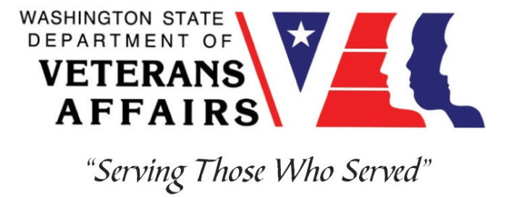
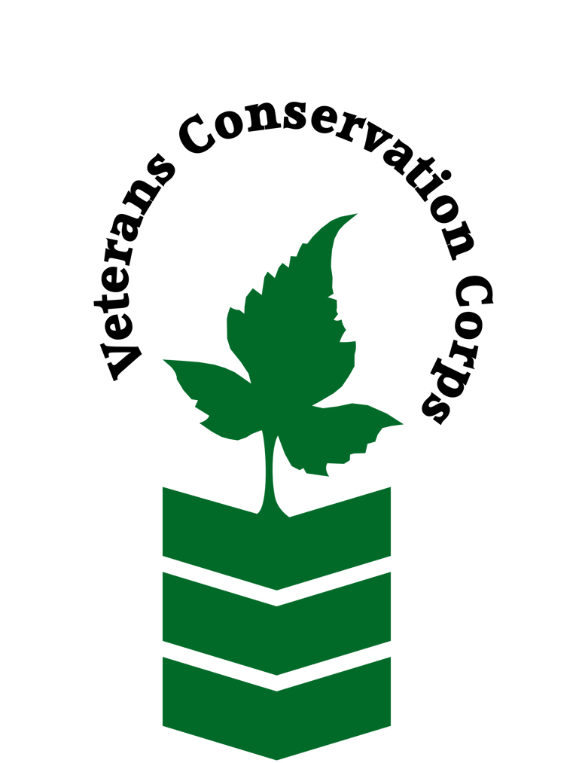

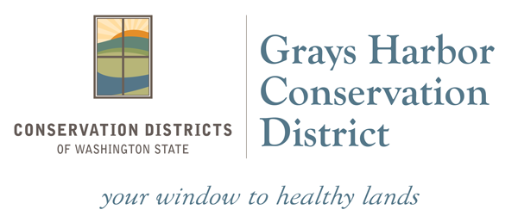

330 W Pioneer Avenue Suite D
Montesano, WA 98563
https://www.graysharborcd.org/
Veterans Conservation Corps Internship Program
with the
Grays Harbor Conservation District

General Description

The Grays Harbor Conservation District (GHCD) provides technical assistance, design services, and implementation of projects that address natural resource concerns and/or restore habitat for fish and wildlife in Grays Harbor County. The intern will join a 3-person restoration crew to work on a variety of habitat restoration projects.

Position Description

The following are examples of typical work duties but are not a comprehensive list:
- Planting native riparian trees and shrubs at restoration projects on private and public lands
- Maintenance/irrigation of native riparian tree and shrub plantings
- Mechanical/chemical treatment of invasive plant species
- Installation of woody hand-built in-stream restoration structures such as beaver dam analogues or post assisted log jams
- Installation of livestock exclusion fences
- Collection of field data on plant survival, invasive plant treatment effectiveness, and in-stream restoration effectiveness
Other work such as conducting basic forest inventory, habitat surveys, fish barrier assessment surveys, and collecting topographic survey data may be assigned as needed.

Schedule and Compensation

This 6-12 month internship has a flexible start date, and includes a VCC stipend of $1800/month for a full-time internship (~40 hours/week) or $900/month for a part-time internship (~20 hours/week) to help cover living expenses.

A typical work week will be Monday through Thursday from 7 am to 5:30 pm. Alternative hours and flexible scheduling to meet the intern’s needs will be discussed on a case-by-case basis.

Requirements

- Must be a United States military veteran to be eligible for this position
- Must have dependable transportation to and from the Grays Harbor Conservation District office in Montesano
- Must be able to work Monday-Thursday

Preferred Knowledge, Skills, and Abilities

This is considered an entry level position and no experience is required. Applicants with the following skills, knowledge, and abilities will be given preference:

- Currently possess or be able to obtain a valid driver’s license
- Experience working on a crew to perform time-sensitive construction projects on private and public property
- Experience implementing safety practices in the field with and without supervision
- Experience operating hand tools and power tools (chainsaws, brushcutters, augers, etc)
- Able to lift up to 50-lbs
- Able to consistently perform hard labor in all outdoor conditions
- Able to take direction and work as a member of a team
- Motivated and enthusiastic
- Comfortable speaking to landowners and other members of the public about projects

Training

All necessary training required to perform the essential functions/duties is provided on the job.

In addition to on-the-job training, this position may include the following formal trainings and certifications to aid in personal & professional development:

- Veterans Cultural Competency Training
- CPR/First Aid
- Posttraumatic Growth Training
- PTSD/TBI/Mental Health/ Suicide Awareness & Prevention
- WDVA Veteran Peer Corps Certification
- VCC Annual Training (every August)
- Environmental conservation conferences/symposiums/workshops
- Other trainings/certifications as available and desired by intern

Apply

All applicants must pass a background check.

To apply, email a resume, a copy of your DD214, a copy of your current driver’s license, and a cover letter explaining your interest in this internship to:

Kim Pham
Veterans Conservation Corps Program Manager
kim@dva.wa.gov

Questions?

To learn more about the Veterans Conservation Corps, contact:

Kim Pham
Veterans Conservation Corps Program Manager
kim@dva.wa.gov

For more information about Grays Harbor Conservation District:

Charly Kearns
Riparian Restoration Coordinator
ghcdriparian@gmail.com

