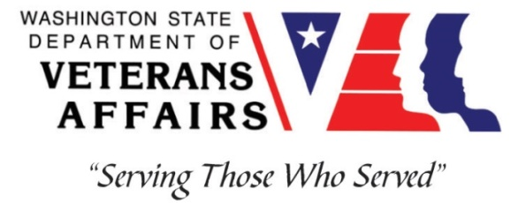
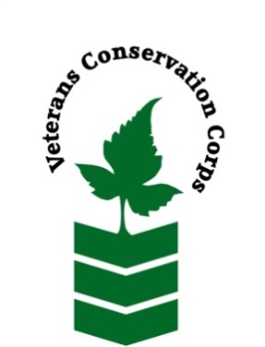
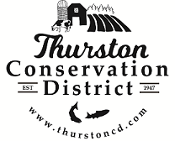
2918 Ferguson St SW Tumwater, WA 98512
Phone: 360-754-3588
www.thurstoncd.com

Veterans Conservation Corps Crew Internship
with the
Thurston Conservation District

Job Description
This position will work on a 4-person field crew under the supervision of the Thurston Conservation District (TCD) Habitat Team. The crew will work on meaningful habitat restoration projects in rural areas within Thurston County to serve their community by improving water quality, enhancing wildlife habitat, and prevent the spread of invasive weeds. The crew will work on public and private properties such as farms and conservation lands, to achieve individual, local and regional resource conservation and restoration goals in Thurston County. Field work activities will include planting native trees and shrubs along rivers and streams, controlling or removing invasive vegetation, implementing erosion control techniques, and participating in salmon recovery projects.

- Work week is Monday-Thursday, 7am-5:30pm
- Pay is in the form of a $2,000 monthly stipend to assist with living expenses
- Internship Term: April 1 - October 31, 2022. Position open until filled.
- All safety equipment (gloves, hard hats, eye protection, ear protection, rain gear etc.) is provided

Requirements
- Must be a United States military veteran to be eligible for this position
- Must have dependable transportation to and from the Thurston Conservation District office
- Must be able to work Monday-Thursday, 7am-5:30pm
- Must be able to work outdoors, in all terrains and weather conditions
- Must be able to take direction and work cohesively with a team
- Must be willing and able to learn new skills
- Must be able to communicate and work with a wide diversity of people

Preferred Knowledge, Skills, and Abilities

This is considered an entry level position and no experience is required. Applicants with the following skills, knowledge, and abilities will be given preference.

- Currently possess or be able to obtain a valid driver’s license
- Experience working on a crew to complete time-sensitive projects on private or public property
- Experience implementing safety practices in the field with and without supervision
- Experience operating hand tools and power tools
- Experience operating heavy equipment (mini-excavator, backhoe, etc.)
- Able to lift up to 50-lbs
- Able to operate a motor vehicle and haul a trailer
- Comfortable working with chemicals like pesticides and fertilizers
- Possession of or interest in obtaining a Pesticide Applicators License
- Comfortable speaking to landowners and other members of the public about projects
- Motivated and enthusiastic to work and learn

Training

All necessary training required to perform the essential functions/duties is provided on the job.

In addition to on-the-job training, this position may include the following formal trainings and certifications to aid in professional development and job training:
- Plant identification
- Habitat restoration and vegetation management techniques
- VCC orientation
- Veterans Cultural Competency Training
- Posttraumatic Growth Training
- PTSD/TBI/Mental Health/ Suicide Awareness & Prevention
- WDVA Veteran Peer Corps Certification
- VCC Annual Training (every August)
- Environmental conservation conferences/symposiums/workshops
- Other trainings/certifications as available and desired by intern

Apply

All applicants must pass a background check.

To apply for this internship, email a copy of your DD214 or service discharge certificate, a copy of your driver license, a resume, and a cover letter explaining your interest in this internship to:

Kim Pham
Veterans Conservation Corps Program Manager
kim@dva.wa.gov

Questions?

To learn more about the Veterans Conservation Corps, contact:

Kim Pham
Veterans Conservation Corps Program Manager
kim@dva.wa.gov

For more information about the job requirements, contact:

Mara Healy
Thurston Conservation District
mhealy@thurstoncd.com
360-999-0464

