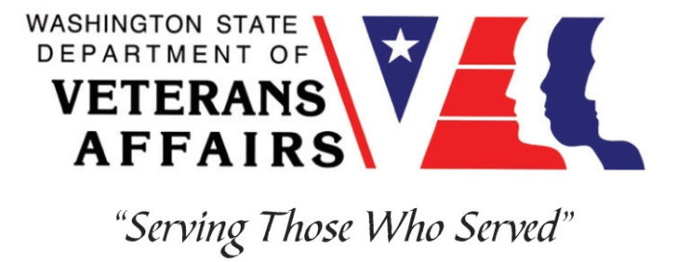
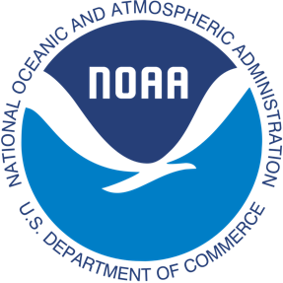
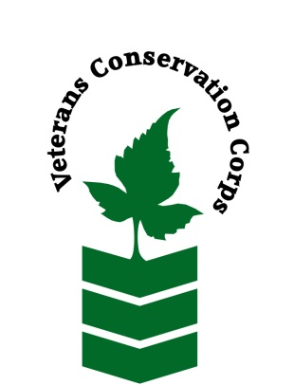

Northwest Fisheries Science Center, 2725 Montlake Blvd E Seattle, WA 98112
(206) 860-3291
https://www.nwfsc.noaa.gov/

NOAA WDVA Veterans Conservation Corps Fisheries Internship Program

***This position requires the applicant to be a United States military veteran***

This NOAA VCC Washington Fisheries Internship is dedicated to Casey Rice (1964-2016), a fisheries biologist and former Station Chief for NOAA's Mukilteo research station. Casey was a great scientist with an extraordinary passion for helping others. His enthusiasm was infectious, and he delighted to share his vision of restoring Puget Sound estuaries. He was also a strong advocate for mentorship, and he spearheaded this veteran internship program which enables interns to take on their own field-based research projects, get the results published in peer reviewed journals, and present their findings to fellow scientists. The Rice Family had a commitment to public service.

General Description
This position is with the Fish Ecology Division of the Northwest Fisheries Science Center (http://www.nwfsc.noaa.gov). Much of the research is dedicated to projects that protect juvenile salmon, forage fish, and associated nearshore habitats. A significant portion of the work is conducted in the field (Skagit and Snohomish River deltas, Elwha River nearshore, etc) and at the NWFSC Montlake facility in Seattle, WA.

In honor of Casey Rice’s passion for all of Puget Sound, this position will have a broad geographic reach. The intern will have an opportunity to become involved in the research of long-term, watershed-scale response of salmon populations and associated habitats to stream and watershed restoration/remediation actions. In addition, the veteran intern will understand how life history strategies, genetics, and associated habitats influence salmon and steelhead recovery.

Position Description
As part of the Fisheries ecology team, the intern will have the opportunity to assist with many projects, and gain a variety of research experiences with different mentors. Two field projects on which the intern will focus in particular are nearshore responses to Elwha River dam removal, and Snohomish/Skagit River restoration monitoring.

The Elwha dam removal project is the largest of its kind in the world. Freshwater and Nearshore/estuarine ecosystem responses include changes to the aquatic habitat, the food web, and all aspects of the forage fish and salmon ecological parameters. ESA-listed and non-listed species are affected.

The Skagit River Intensively Monitored Watershed (IMW) program affords an applicant the opportunity to collect field samples and process long-term robust datasets. The Snohomish River monitoring will include sampling fish assemblages and water quality throughout the mainstem and tributaries. The team is also collaborating with the Navy to evaluate estuarine habitat for salmon transiting from upstream restoration locations through the Everett Naval Station facility adjacent to the mouth of the Snohomish River.

Laboratory duties include processing field collected samples. Office duties include maintaining records of experiential systems and rearing activities, data entry, database management, and data analysis. Some local and overnight travel may occasionally be required. Transportation and lodging will be provided while in the field. Intern will be expected to work on, and may operate, GOV and Small boats as part of the training/certification/field operation opportunities provided.

In honor of Casey Rice’s passion for learning and collaboration, this internship position will dedicate the final month (month 7) to research presentations, networking, and building professional relationships. The intern will be expected to formally present research findings and data collection during their final month, format to be discussed. In addition, as collaboration is key to many scientific pursuits, the intern will attend a reputable scientific conference as a poster presentation. In order to promote a healthy work-life balance, this intern is encouraged to pursue activities and/or training that promotes equilibrium, supports veteran transition to civilian life, and/or eco-therapy opportunities. Throughout the 7 months, NOAA mentors will focus on the intern’s professional development.

This 7-month internship will begin on March 1, 2023 (flexible start date will be considered) and includes a stipend of $1,200/month for a part-time internship (approximately 20 hours/week) or $2,400/month for a full-time internship (approximately 40 hours/week) to help cover living expenses. This internship position will remain open until filled.

Schedule:

We work Monday through Friday from 8 to 5, with occasional extended field days not to exceed 40 hours per week. Alternative hours and flexible scheduling to meet the intern’s needs will be discussed on a case-by-case basis.

Required Skills, Knowledge, and Abilities

- This position requires the applicant to be a veteran of the United States Uniformed Services.

Preferred Qualities
Minimum qualifications are not established for this position; however, applicants with the following skills, knowledge, and abilities will be given preference.
- Motivated and enthusiastic, with an interest in marine biology/fisheries
- Ability to work independently and as a member of a crew
- Strong self-initiative, and good attention to detail
- Experience with operation of tools is preferred but not required
- Experience with MS Word, Excel, Access and Powerpoint
- Familiarity the Pacific Northwest marine environment and marine fishes of Washington waters is preferred
- Experience working on small boats and knowledge of general boat maintenance/operations will be given preference
- Follows appropriate safety practices in the lab and the field

Physical Requirements:

- Ability to work outdoors in any weather condition
- Work on small boats in calm and rough seas.
- Ability to complete training to operate GSA vehicles towing trailers and assist with launch of related vessels
- Ability to lift up to 40 pounds and to pull nets against current
- Ability to hike up to 5 miles in rough terrain carrying up to 30 lbs of equipment

Training

All necessary training required to perform the essential functions/duties is provided on the job.

In addition to on-the-job training, this position may include the following formal trainings and certifications to aid in personal & professional development:
- NOAA Small Boat Program certification for operation of boats and trailers towed by GSA vehicles
- Environmental conservation conferences/symposiums/workshops
- Posttraumatic Growth Training
- PTSD/TBI/Mental Health/ Suicide Awareness & Prevention
- Veteran Peer Support Training
- VCC Annual Training (every August)
- Other trainings/certifications as available and desired by intern
Apply

All applicants must pass a background check.

To apply, email a copy of your DD214 or service discharge certificate, a copy of your driver license, a resume, and a cover letter explaining your interest in this internship to:

Kim Pham
Veterans Conservation Corps Program Manager
kim@dva.wa.gov

Questions?

To learn more about the Veterans Conservation Corps Internship Program, contact:

Kim Pham
Veterans Conservation Corps Program Manager
kim@dva.wa.gov

For more information about NOAA, contact:

Anna Kagley or Sarah Morley
Research Leads

Anna Kagley Sarah Morley
Anna.kagley@noaa.gov Sarah.morley@noaa.gov
(206) 860-3291 (206) 860-6780

