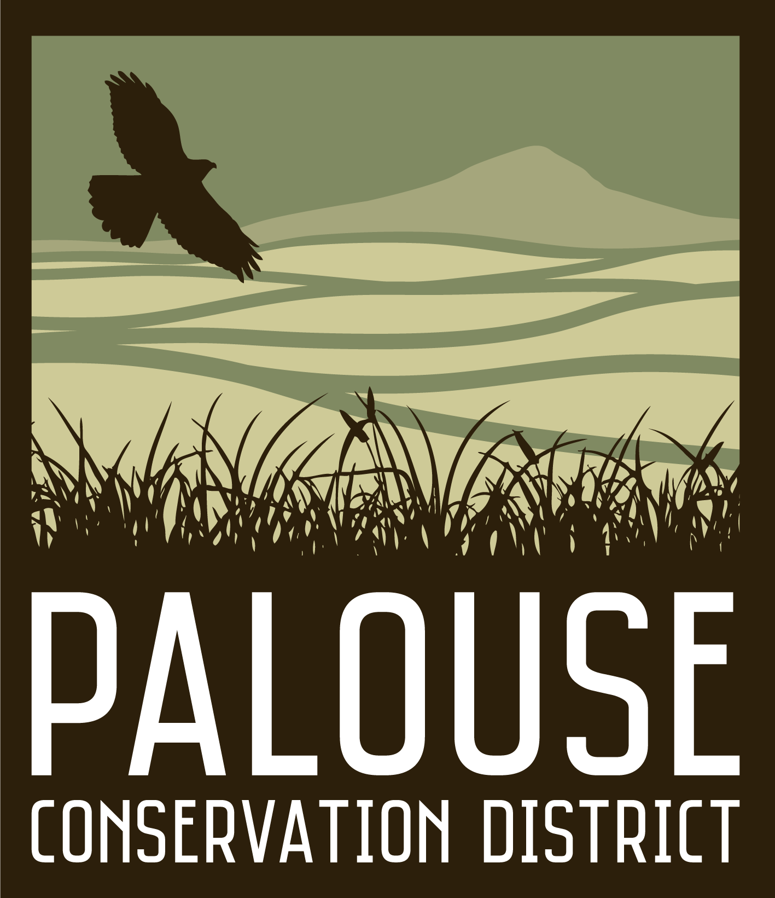
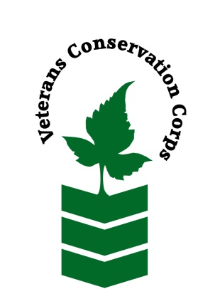
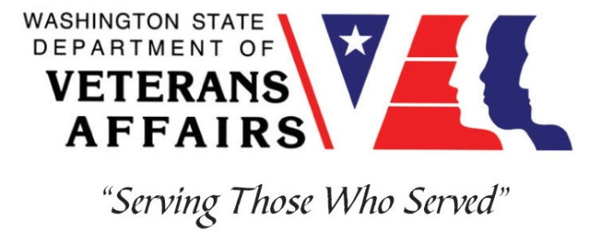

Palouse Conservation District, 1615 NE Eastgate Blvd., Suite H, Pullman, WA 99163
Phone 509-332-4101
www.palousecd.org

Veterans Conservation Corps
with
Palouse Conservation District
Natural Resource Conservation Internship

General Description

Palouse Conservation District (PCD) is a local, grant funded organization that fosters voluntary conservation of natural resources by providing education, technical expertise, and on-the-ground project implementation to help members of our community reach their conservation goals. PCD is involved in a wide variety of programs and projects in the community including riparian area restoration, research and monitoring, education and outreach, conservation agriculture, and habitat enhancement. By working closely with local landowners and land managers, PCD is improving soil health, water quality, and fish and wildlife habitat on the Palouse.

Position Summary

Primary duties of this position are to assist PCD staff in the implementation and maintenance of riparian restoration projects on private land throughout southeast Whitman County. Other duties will include but are not limited to assisting PCD staff with water quality and soil health monitoring, vegetation monitoring, and engaging the community through education and outreach events. This is primarily an outdoor field work position, but some office work will be required during the winter months. The goal of this position is to provide the intern with a wide range of experiences in all program areas at PCD.

Schedule and Compensation

This 6-month internship, with possibility of extension, will begin in May 2023 and includes a monthly stipend to assist with living expenses: $2400 for a full-time internship (approx. 40 hrs/week) and $1200 for a part-time internship (approx. 20 hrs/week). Typical work week is Monday- Friday with occasional night and weekend work for outreach events. Position open until filled.

Requirements

- Must be a veteran of the United States uniformed services
- Must have dependable transportation to and from the Palouse Conservation District office
- Must currently possess a valid driver’s license

Preferred Knowledge, Skills, and Abilities

This is considered an entry level position and no experience is required. Applicants with the following skills, knowledge, and abilities will be given preference.

- Experience working on a crew to perform time-sensitive construction or restoration projects
- Experience implementing safety practices in the field with and without supervision
- Experience operating power and hand tools (brush cutters, mowers, augers, drills, saws, etc.)
- Experience properly mixing and applying pesticides
- Able to lift up to 40-lbs
- Able to consistently perform strenuous labor in all outdoor conditions
- Able to take direction and work as a member of a team
- Able to operate a motor vehicle and haul a trailer
- Ability to identify common riparian plants of eastern Washington
- Experience using the Microsoft Office Suite of programs
- Comfortable and willing to speak to landowners, students, and other members of the public about natural resource issues to promote the goals and mission of PCD

Training

All necessary training required to perform the essential functions/duties is provided on the job.

In addition to on-the-job training, this position may include the following formal trainings and certifications to aid in personal & professional development:

- Chainsaw safety
- ATV/UTV safety training
- Washington Pesticide Applicator License
- Plant Identification
- WET Watershed Education Training
- Posttraumatic Growth Training
- PTSD/TBI/Mental Health/ Suicide Awareness & Prevention Training
- Veteran Peer Support Training
- Environmental conservation conferences/symposiums/workshops
- Other trainings/certifications as available and desired by intern

Apply

All applicants must pass a background check.

To apply, email a resume, a copy of your DD214 or service discharge certificate, a copy of your current driver’s license, and a cover letter explaining your interest in this internship to:

Kim Pham
Veterans Conservation Corps Program Manager
kim@dva.wa.gov

Questions?

To learn more about the Veterans Conservation Corps, contact:

Kim Pham
Veterans Conservation Corps Program Manager
kim@dva.wa.gov

For more information about Palouse Conservation District, contact:

Andrew Mackey
Resource Conservation Program Coordinator
andrewm@palousecd.org
509-553-3032

