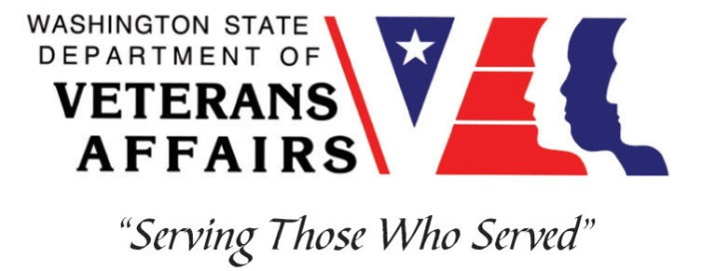
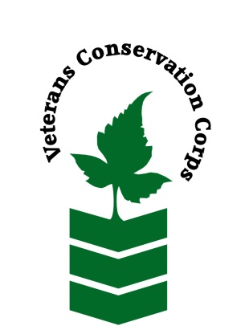
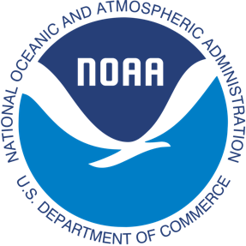
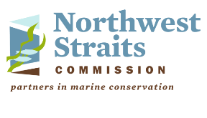

Northwest Straits Commission, 10441 Bayview-Edison Rd, Mount Vernon, WA 98273
https://nwstraits.org/
NOAA WDVA Veterans Conservation Corps Fisheries Internship Program
with the
Northwest Straits Commission

***This position requires the applicant to be a veteran of the U.S. Uniformed Services***

Program Description

The NOAA WDVA Veterans Conservation Corps Fisheries Internship Program is a Washington-based internship focused on marine science and stewardship of coastal resources. Since 2016, NOAA has been funding these internships and partnering with the WDVA Veterans Conservation Corps to deliver high level science-based experiences at NOAA Research Centers and NOAA partner organizations throughout Washington. This internship adds the Northwest Straits Commission to this NOAA and WDVA Veterans Conservation Corps partnership. The internship will be supervised by the Northwest Straits Commission. The internship will primarily be field based along with both virtual and in-person meetings at Northwest Straits Commission offices. Coordination and support will be provided by the VCC and NOAA.

General Description

This position is with the Northwest Straits Commission (NWSC) (https://nwstraits.org/) housed at the Padilla Bay National Estuarine Research Reserve (NERR) in Mount Vernon, WA. The NWSC and NERR are housed within the WA Department of Ecology. The Northwest Straits Commission mission is to protect and restore the marine waters, habitats, and species of the Northwest Straits region to achieve ecosystem health and sustainable resource use. The mission is achieved by providing coordination, technical, and funding support to local volunteer based Marine Resources Committees in seven counties of North Puget Sound. Northwest Straits Commission staff also strive to connect Marine Resources Committee (MRC) priorities with regional efforts to protect and restore Puget Sound through collaborative conservation. Staff perform their duties from home and in the field with periodic in-person meetings at the Northwest Straits Commission offices located at the Padilla Bay NERR. Meetings are also held using virtual technology.

Diversity, equity, inclusion, and respect (DEIR) are core values central to the NWSC’s work. We strive to be a workplace where we are esteemed for sharing our authentic identities, while advancing our individual professional goals and collaborating to protect, preserve, and enhance the environment for current and future generations.
Diversity: We celebrate and appreciate diversity; our unique perspectives and abilities enrich us all and lead to innovative approaches and solutions.

Equity: We champion equity, recognizing that each of us need different things to thrive.

Inclusion: We intentionally create and hold space so that we all have meaningful opportunities to participate and contribute to the NWSC’s work.

Respect: We treat each other with respect and dignity, acknowledging the inherent worth of our diverse perspectives and lived experiences, even in times of uncertainty and disagreement.
We believe that DEIR is both a goal and an action. We are on a journey, honoring our shared humanity and taking steps to demonstrate our commitment to a vision where each of us is heard, seen, and valued.

The NWSC follows all WA Department of Ecology COVID-19 safety procedures. These rules are updated regularly in adherence with new public health guidance.

Position Description

This position will work collaboratively with NWSC staff, volunteers, and partners. Tasks will include both field and office work. The intern will have the opportunity to contribute to a community-based effort to protect native species and habitat from invasive European green crab and participate in community-based symposiums and board meetings. The intern will learn strategies for natural resource protection through community engagement approaches.

Green crabs are among the top 100 most invasive species in the world and pose an emerging threat to eelgrass and native shellfish. In 2020, the NWSC developed a partnership with the WA Dept. of Fish and Wildlife and WA Sea Grant to trap and remove green crab from Drayton Harbor, located in Whatcom County. Trapping efforts expanded in 2022 to include sites in Skagit County and additional sites in Whatcom County. This partnership will continue through 2023. This position will work alongside multiple partners to trap and remove green crab, while also developing community support and collaboration for prolonged program success.

This position’s tasks may include:
- Conducting removal trapping efforts in high-density green crab locations and early detection surveys in potential green crab habitat.
- Recording field data during green crab trapping efforts, including location of trap placement, identification of nearshore and marine species, and condition of green crabs captured.
- Assisting with landowner communication and community education and outreach on green crabs.
- Assisting with project meeting and workshop notetaking and summaries.
- Collaborating with technical experts from the WA Dept. of Fish and Wildlife, WA Sea Grant, local volunteers, and other partners.
- Communicating and reporting on project progress and needs to NWSC staff.
- Other related tasks based on intern’s educational and professional interests.

Travel to project site locations is required, though flexible meeting locations and carpool options can be discussed to meet intern’s needs.

There are also anticipated to be additional opportunities to network and communicate with NOAA research staff and communicate the results and experiences of this internship.

Schedule and Compensation

This 5-month internship includes a stipend of $2400/month for a full-time internship (approximately 40 hours/week) to help cover living expenses. This internship will be available April 3, 2023 – September 30, 2023 with the possibility of extension to November 30, 2023. Position open until filled, and start date is flexible.

Although we strive to maintain a M-F schedule, green crab trapping is tide dependent and varies each week. Some weekend work may occur to take advantage of favorable tides and outreach opportunities. Green crab trapping fieldwork will generally occur four to five days per week and 6-10 hours per day. Extended field days will not exceed 40 hours per week. In general, virtual or in office meetings will occur on non-field days. Alternative hours and flexible scheduling to meet the intern’s needs will be discussed on a case-by-case basis.

Required Skills, Knowledge, and Abilities

- This position requires the applicant to be a veteran of the United States Uniformed Services to be eligible for this position
- Per Governor Inslee’s Directive 22-13.1, candidates must be fully vaccinated effective November 4, 2022. Providing proof of being fully vaccinated is a condition of this position and your vaccine status will be verified prior to starting work. Being fully vaccinated means two weeks after you have received the second dose in a two-dose series of a COVID-19 vaccine or a single-dose COVID-19 vaccine authorized for emergency use, licensed or otherwise authorized or approved by the U.S. Food and Drug Administration or listed for emergency use or otherwise approved by the World Health Organization.

Preferred Qualities
Minimum qualifications are not established for this position; however, applicants with the following skills, knowledge, and abilities will be given preference.
- Motivated and enthusiastic
- Interest in learning about the Pacific Northwest marine environment, marine fishes, and nearshore organisms of Washington waters
- Interest and willingness to work with volunteers
- Ability to work independently and as a member of a small crew
- Strong self-initiative and good attention to detail
- Follows appropriate safety practices in the field
- Experience with MS Word, Excel, and PowerPoint

Physical Requirements:

- Ability to traverse difficult terrain including steep embankments and deep mud flats while manually transporting heavy traps
- Ability to work outdoors in adverse weather conditions

Training

All necessary training required to perform the essential functions/duties is provided on the job.

In addition to on-the-job training, this position may include the following formal trainings and certifications to aid in personal and professional development:

- Posttraumatic Growth Training
- PTSD/TBI/Mental Health/ Suicide Awareness & Prevention
- Veteran Peer Support Training
- Environmental conservation conferences/symposiums/workshops
- Other trainings/certifications as available and desired by intern

Apply

All applicants must pass a background check.

To apply for this internship, email a copy of your DD214 or service discharge certificate, a copy of your driver license, a resume, and a cover letter explaining your interest in this internship to:

Kim Pham
Veterans Conservation Corps Program Manager
kim@dva.wa.gov

Questions?
To learn more about the NOAA WDVA Veterans Conservation Corps Fisheries Internship Program, contact:

Kim Pham
WDVA
Veterans Conservation Corps Program Manager
kim@dva.wa.gov

John Floberg
NOAA
Marine Habitat Resource Specialist
John.r.floberg@noaa.gov

For more information about NWSC, visit www.nwstraits.org or contact:

Lucas Hart
Executive Director
Northwest Straits Commission
hart@nwstraits.org
360-391-7190

