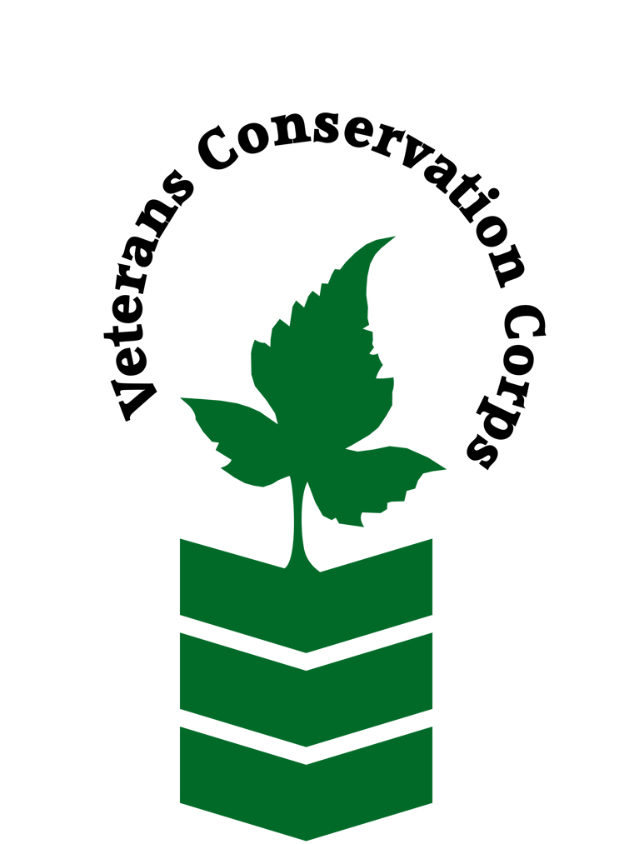
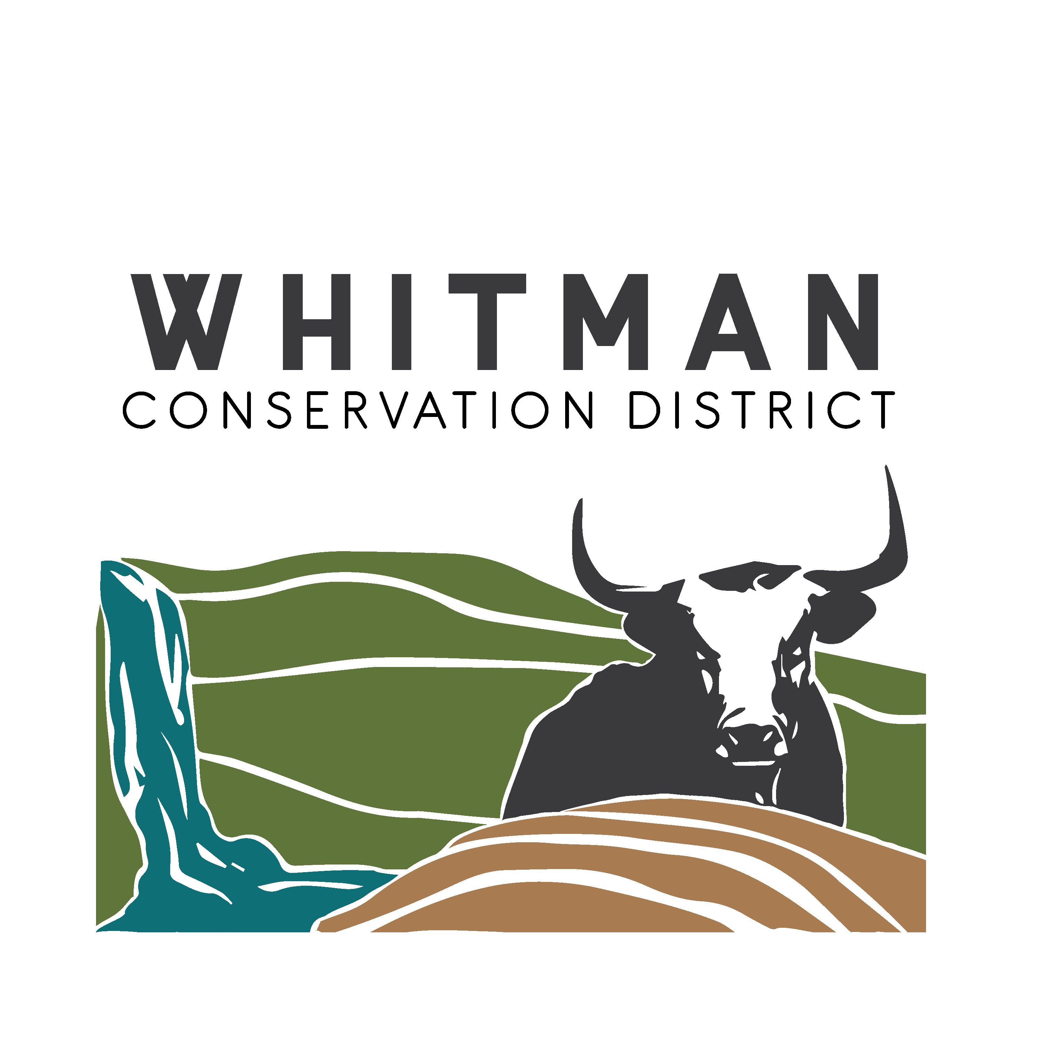

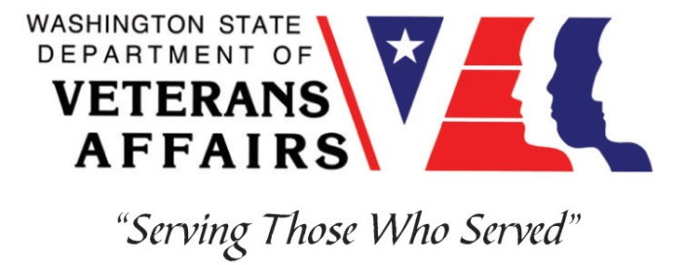

601 North Main Suite #A
Colfax, WA 99111
www.whitmancd.org

Veterans Conservation Corps Internship Program
with
Whitman Conservation District

General Description

The Whitman Conservation District (WCD) provides technical assistance, design services, and construction on projects that address natural resource concerns and/or restore habitat for fish and wildlife. The Conservation District primarily works with stakeholders on riparian and wildlife planting projects by clearing and preparing planting areas and then planting and maintaining trees and shrubs, stream habitat enhancement projects, forest resiliency projects, and other outdoor work related to WCD projects and priorities. WCD engages the community through volunteer service-learning events, and thus internship candidates must be comfortable working with community members from all ages and backgrounds.

Position Description

- Work on all aspects of riparian restoration including but not limited to preparing, implementing, planting, monitoring, and maintaining project sites
- Navigate across variable terrain in order to conduct CRP checks or obtain Soil samples across agricultural fields
- Operate and maintain hand tools and small engine machinery: weed whackers, gas-powered augers, post-pounders, riding/push lawn mowers, etc.
- Harvest plant materials and install woody structures in streams
- Work with a team of natural resource professionals focused on local grassroots conservation efforts. Partners include: Other Conservation Districts, WA Dept. of Ecology, WA Fish & Wildlife, WA Dept. Natural Resources, County Parks
- Gain valuable qualifications and job skills (e.g. plant propagation, proper use of tools, streambank bioengineering, native and invasive plant ID)

Schedule and Compensation:

This 6-month internship, with the possibility of extension, will begin in June 2023 and includes a VCC stipend of $2400/month for a full-time internship (~40 hours/week) or $1200/month for a part-time internship (~20 hours/week) to help cover living expenses, as well as a supplemental stipend from WCD of up to $800/month (full-time) and $400/month (part-time) depending on prior work experiences.

A typical work week will be Monday through Friday from 7 am to 4:00 pm. Work days and times may change to accommodate project needs and/or weather. Alternative hours and flexible scheduling to meet the intern’s needs will be discussed on a case-by-case basis.

Requirements

- Must be a veteran of the U.S. Uniformed Services to be eligible for this position
- Must have dependable transportation to and from the Whitman Conservation District office
- Must be able to work Monday-Friday.

Preferred Knowledge, Skills, and Abilities

This is considered an entry level position and no experience is required. Applicants with the following skills, knowledge, and abilities will be given preference.

- Currently possess or be able to obtain a valid driver’s license
- Experience working on a crew to perform time-sensitive construction projects on private and public property
- Experience implementing safety practices in the field with and without supervision
- Experience operating hand tools and power tools (chainsaws, weedwhackers, augers, etc)
- Experience operating heavy equipment (mini-excavator, tractors, etc.)
- Experience in landscape construction
- Able to lift up to 50-lbs
- Able to consistently perform hard labor in all outdoor conditions
- Able to take direction and work as a member of a team
- Able to operate a motor vehicle and haul a trailer
- Motivated and enthusiastic
- Comfortable speaking to landowners and other members of the public about projects

Training

All necessary training required to perform the essential functions/duties is provided on the job.

In addition to on-the-job training, this position may include the following formal trainings and certifications to aid in personal & professional development:

- CRP check training with the NRCS
- Soil Sampling through the WSDA
- Veterans Cultural Engagement Training
- Posttraumatic Growth Training
- PTSD/TBI/Mental Health/ Suicide Awareness & Prevention
- Veteran Peer Support Training
- Environmental conservation conferences/symposiums/workshops
- Growing your veteran-owned small business
- Whole Farm Planning and Agricultural Entrepreneurship
- Other trainings/certifications as available and desired by intern

Apply

All applicants must pass a background check.

To apply, email a resume, a copy of your DD214 or service discharge certificate, a copy of your current driver’s license, and a cover letter explaining your interest in this internship to:

Kim Pham
Veterans Conservation Corps Program Manager
kim@dva.wa.gov

Questions?

To learn more about the Veterans Conservation Corps, contact:

Kim Pham
Veterans Conservation Corps Program Manager
kim@dva.wa.gov

For more information about Whitman Conservation District:

Josh Larsen
District Manager
jlarsen@whitmancd.org

