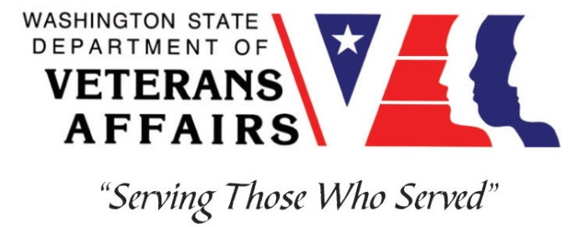
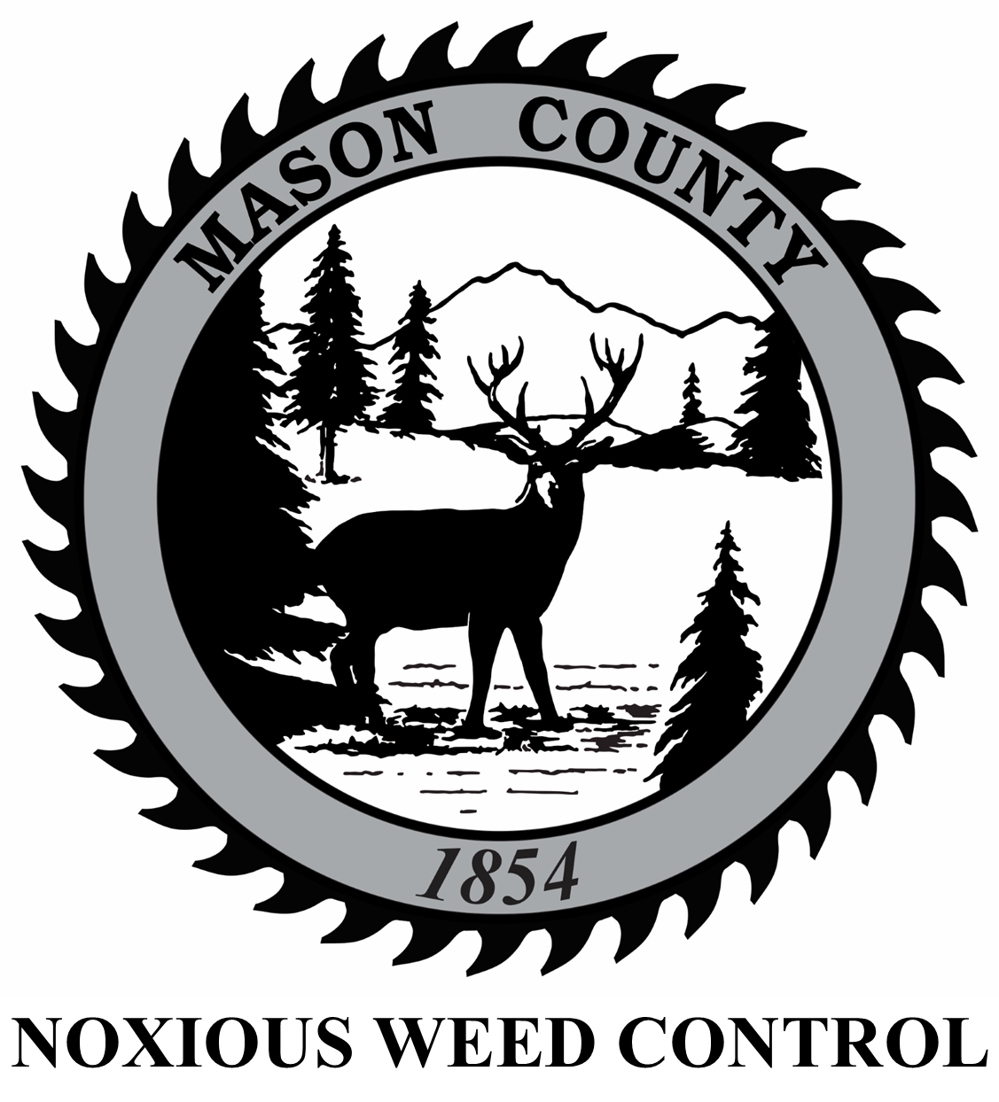

303 N. Fourth Street
Shelton, WA 98584
https://extension.wsu.edu/mason/
Veterans Conservation Corps Internship Program
with
Mason County WSU Extension

Program Overview

Washington State University Mason County Extension connects the people of Mason County to the research and knowledge bases of the state’s land grant research university by providing solutions to local problems and stimulating local economies. County-based educators work with partners in the Mason County community to provide educational programs and leverage the broad resources of a major university to resolve issues and create a positive future for the residents of Mason County. Mason County WSU Extension’s stated mission is to help people develop leadership skills and use research-based knowledge to improve their economic status and quality of life through lifelong learning.

Mason County WSU Extension programs include SNAP-Ed, 4-H Youth Development, Small Farms, and Master Gardeners. In addition to these programs, the Mason County Noxious Weed Control Program partners with Mason County WSU Extension. This position will have the potential to support Mason County Noxious Weed Control, Small Farms, Master Gardeners, and 4-H Youth Development programming.

Program Descriptions

The Mason County Noxious Weed Control Board (MCNWCB) is a county agency that aims to protect the citizens, natural resources, and agricultural resources of Mason County from the degrading effects of noxious weeds. MCNWCB endeavors to develop programs that reflect local priorities, meet the needs of county landowners and residents, and carry out the mandate of the Washington State noxious weed law, RCW 17.10. Mason County Noxious Weed Control Program staff are available for community education programs and consultations with landowners to discuss weed management options, including measures to prevent the establishment of noxious weeds on their own property using integrated pest management (IPM) principles.

The WSU Extension Mason County Small Farms Program partners with regional organizations and university resources to help safeguard Mason County’s diverse natural resources through building public support for agriculture, helping farmers adopt sustainable economic, social, and environmental practices, unifying farmers and consumers, and preserving Washington’s farmland. The program provides educational opportunities, access to resources, and facilitates projects to improve local food security efforts.

The WSU Extension Mason County Master Gardener Program was formed in 1973 in King and Pierce counties as a response to the general public’s rapidly growing interest in urban horticulture. It has grown over 50 years into a nationwide program with the mission to “engage university-trained volunteers to empower and sustain diverse communities with relevant, unbiased, research-based horticulture and environmental stewardship education.” Mason County Certified Master Gardener’s fulfill this mission through hosting plant clinics, creating demonstration gardens, offering community garden beds, providing educational workshops, growing food for the local food bank, and supporting school gardens.

The WSU Extension Mason County 4-H Youth Development program is a community of young people who are learning leadership, citizenship, and life skills. 4-H your programs provide opportunities for youth to develop skills they can use now and throughout life.

Position Summary

This position may include the following responsibilities:

- Assists with multiple community education and outreach events, including noxious weed workshops and events, Master Gardener programs, Small Farms workshops, and 4-H Youth Development activities such as Panhandle Lake 4-H Summer Youth Camp and the Grays Harbor County Fair
- Assists with creating and distributing education and outreach materials such as flyers, brochures, handouts, posters, social media posts, etc. for all programs
- Conducts field inspections and surveys utilizing GPS/GIS for noxious weeds within the county boundaries to assist with noxious weed control enforcement according to 17.10 RCW, while keeping accurate records of all property visits and surveys data
- Participates directly in weed control activities, including the use of herbicides and physical removal, and may work in various physically challenging and hazardous terrains and weather
- Maintains county workplace and vehicles in a clean and organized manner

Schedule and Compensation

This 6-month internship, with possibility of extension, begins in July 2023 and includes a VCC stipend of $2400/month for a full-time internship (~40 hours/week) or $1200/month for a part-time internship (~20 hours/week) to help cover living expenses. Position open until filled.
Schedule is flexible and can be 8- or 10-hour days, depending on staff activities and the time of year. There may be some weekend work opportunities, for staffing volunteer events, etc., but never weekend work requirements. Alternative hours and flexible scheduling to meet the intern’s needs will be discussed on a case-by-case basis.

Training

All necessary training required to perform the essential functions/duties is provided on the job.

In addition to on-the-job training, this position may include the following formal trainings and certifications to aid in personal & professional development:
- Herbicide mixing and application training
- Noxious weed knowledge and identification
- WA Pesticide License education, training, and test (cost covered by the MCNWCB)
- Veterans Cultural Engagement Training
- Environmental conservation symposiums/workshops
- Posttraumatic Growth Training
- PTSD/TBI/Mental Health/ Suicide Awareness & Prevention
- Veteran Peer Support Training
- Other trainings/certifications as available and desired by intern

Requirements
- Must be a veteran of the United States Uniformed Services
- Must have dependable transportation to and from the Mason County WSU Extension building in downtown Shelton, WA

Preferred Knowledge, Skills, and Abilities

This is considered an entry level position and no experience is required. Applicants with the following skills, knowledge, and abilities will be given preference:
- Currently possess or be able to obtain a valid driver’s license
- Experience implementing safety practices in the field with and without supervision
- Able to work outside in inclement weather conditions over uneven terrain
- Able to take direction and work as a member of a team
- Motivated and enthusiastic
- Organized and excellent attention to detail
- Comfortable speaking to landowners and other members of the public
- Basic computer skills and data entry skills (Microsoft Word and Excel)
- Experience working with Microsoft Publisher, Canva, and other similar media-creation platforms
- GIS experience is a plus
- Plant-based background or education is a plus

Apply

All applicants must pass a background check.

To apply, email a copy of your DD214 or service discharge certificate, a copy of your driver license, a resume, and a cover letter explaining your interest in this internship to:

Kim Pham
Veterans Conservation Corps Program Manager
kim@dva.wa.gov

Questions?

To learn more about the Veterans Conservation Corps, contact:

Kim Pham
Veterans Conservation Corps Program Manager
kim@dva.wa.gov

For more information about the Mason County WSU Extension and its programs, contact:

Kela Hall-Wieckert
Mason County Noxious Weed Control Program Coordinator
360-427-9670 ext. 592
Khall-wieckert@masoncountywa.gov

